Subject: SPEAKING 3
Book: Northstar 3 Listening and Speaking
Athors: Helen S. Solorzano – Jennifer P. L. Schmidt
Lecturer: NGUYỄN THỊ THƯ MA.

UNIT 1: ADVERTISING ON THE AIR

ACTIVITY A: PREDICT
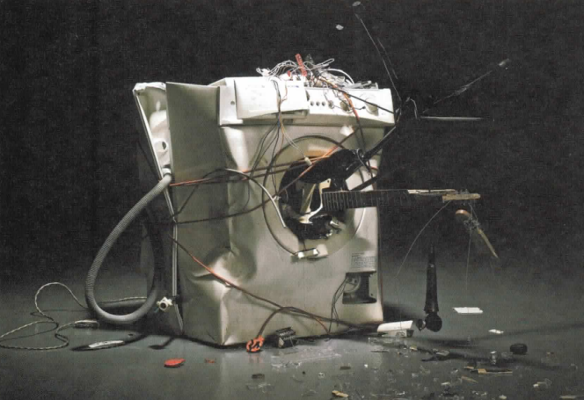
Discuss the questions with the class.
1. Look at the advertisement. What product do you think this company is advertising? (A pain medication)
2. Do you think this is a good ad? Would you buy the product? Why or why not?
3. Look at the title of the unit. What kind of advertising do you think this unit will be about?
ACTIVITY B: SHARE INFORMATION
1. What is an advertisement? (definition, purpose, audience…)
2. Work in a small group. Describe on ad you have seen or heard recently. Discuss whether you liked the ad and why. Use the questions to guide your discussion.
Did the ad have ... ?
- a funny situation
- a good song
- nice-looking people
- a famous person
- information about the product
- (other)
ACTIVITY C: PRODUCTION
Work in a group of four or five. Follow the steps.
Step 1: Plan the ad.
- Choose the product and target audience for your ad.
- Decide on the appeal you will u e and how you will get the consumers' attention.
- Discus other techniques you can use in the ad (music, catchy logan, sound effects, funny voice).
Step 2: Write a script and practice the ad.
- Make sure that each group member has a speaking part and a copy of the script.
- Keep the ad short (about 60 seconds).
- Include an attention grabber.
Step 3: Present the ad to the class. Give a brief introduction about the product and target audience. Then perform the ad.

ACTIVITY D: ALTERNATIVE SPEAKING TOPICS
Discuss one of the topics.
1. There are many unusual places to advertise aside from TV, radio, and magazines. For example, one company covered the wall of a train station in Tokyo with pictures of its product. People could peel the pictures off the wall and take them home. Make a list of unusual methods of advertising that you have seen. Which is the most unusual? Why are advertisers doing this?
2. Children are a big target audience for advertisers. Companies hope that if they start selling product to children at an early age, children will continue to buy the products when they are adult. Some people are against advertising to children. They say that children should not be targets because they are too easily affected by advertising. What is your opinion? Should advertisers be allowed to advertise to children? Why or why not?
ACTIVITY D: RESEARCH
Step 1: Find three magazine ads that grab your attention and bring them to class.
Step 2: Work in small groups. Show your ad to the group and discuss the questions.
- Who is the target audience?
- What techniques does the advertiser use to sell the product?
- Do you think this ad is effective? Why or why not?

UNIT 2: IDENTITY THEFT

ACTIVITY A: PREDICT
Discuss the questions with the class.
1. Look at the photo. What i happening to the woman's picture? Why?
2. Read the title of the unit. What is identity theft?
ACTIVITY B: SHARE INFORMATION
Work in a small group. Read the information and discuss the questions.
Identity theft is a type of fraud. Fraud is a crime in which the criminal, or thief, lies to someone in order to get money or goods. The thieves steal personal information-such as a person's name, address, driver's license, or passport number-and use it to open bank or credit card accounts in the name of the victim, the person harmed. Victims often find out about the theft when they start getting bills for things they didn't buy.
- What are some ways thieves can steal personal information?
- How can you keep your personal information safe?
- How are victims affected by identity theft?
ACTIVITY C: ROLE PLAY
In this activity, you will create and perform a 3-5-minute role play about identity theft. A role play is a short performance. The actors take on roles, or become characters, and act out a situation. Often the situations are similar to experiences that people might have in real life. Try to use the vocabulary, grammar, pronunciation, and language for keeping a conversation going that you learned in the unit.
Work in a group of three. Follow the steps.
Step 1: Choose a situation for the role play. Choose from the following ideas:
- filing a police report
- getting a call from a department store about a bill
- calling a credit card company about a theft
- giving advice to a friend about identity theft
- (your own idea)
Decide on the place, characters, and story. Choose from the following ideas: Place:
- at a police station
- in a department store
- on the phone
Characters (think about age, personality, and feelings about the situation):
- identity theft victim
- police officer
- store employee
- identity thief
- (your own idea)
Story:
- Background : What happened before the role play starts?
- Plot: What happens during the role play?
Step 2: Create the role play. Act like your character and speak naturally. Practice the role play several times.
Step 3: Perform your role play for the class.
our o ACTIVITY D: ALTERNATIVE SPEAKING TOPICS
Discuss one of the topics. Use the vocabulary and grammar from the unit
1. Tell a story about identity theft. It can be from your own experience, or something you heard or read about. Who were the victims? How did the thieve steal their identity? What happened after the theft?
2. More and more criminals are stealing personal information from computers or over the Internet. How can people protect themselves from this kind of crime?
ACTIVITY E: RESEARCH
Step 1: Find out more about identity theft. Choose one topic from the box or think of your own.
child identity theft dumpster diving shoulder surfing
criminal identity theft mortgage fraud skimming
data theft phishing

Step 2: Research the topic on the Internet or in the library. Use the questions to guide your research
1. What is ?
2. Is it a common way to commit identity theft?
3. What can people do to protect themselves against?
Step 3: Share your information with the class.
UNIT 3: ENDURANCE TEST
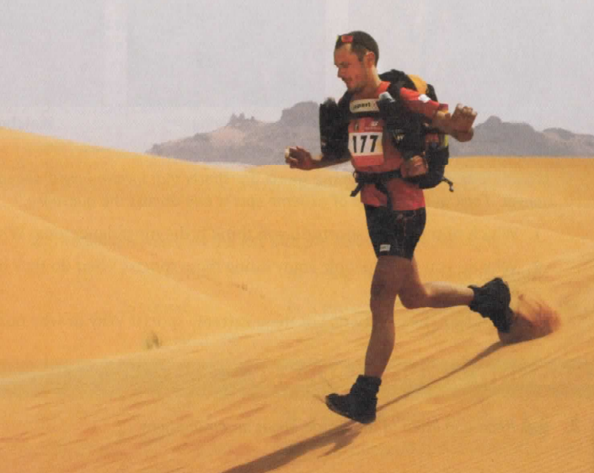
ACTIVITY A: PREDICT
Discuss the questions with the class.
- Look at the photo. Where is this man? What is this sport?
- Read the title of the unit. Endurance is the ability to live with pain and suffering for a long time. What do you think the unit will be about?
ACTIVITY B: SHARE INFORMATION
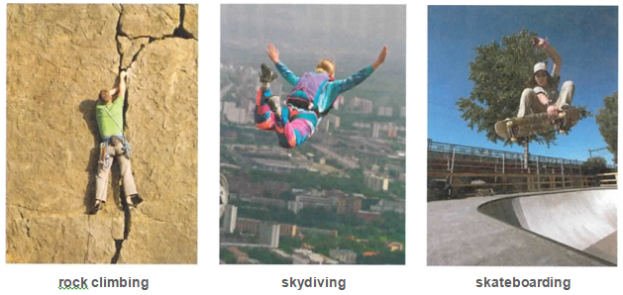
Work in a small group. Extreme sports are sports that involve height, speed, strength, or danger. Look at the photos of extreme sports and discuss the questions.
- Which of the above sports do you think is the most dangerous? Why?
- Why do you think people enjoy doing these sports? What do they like about them?
- Would you like to try one of these extreme ports? Why or why not?
ACTIVITY C: CREATE
1 Think about an important goal you have in your life. It can be a goal in sports, school, work, or other areas.
Consider the examples.
- Learn English
- Become a doctor
- Run in a marathon
- Buy a house
- Travel around the world
2 Work with a partner. Take turns asking and answering questions about your goal. Use the words and phrases from the box in your answers.
- What is your goal? When did you first set your heart on this goal?
- When do you think you will achieve the goal? What stage are you at in the process (beginning, middle, end)?
- How is your experience so far? Do you enjoy it?
- What challenges make it difficult to achieve the goal? Are you ever your own worst enemy? Has anything thrown you for a loop? Please explain.
- What is your motivation for achieving the goal?
- Why do you think you have what it takes to achieve the goal? ls there something unique about you that will help you achieve it?

blow my chance endurance get into
easier said than done format opponent

Example
STUDENT A: What is your goal?
STUDENT B: I want to be a newspaper reporter.
STUDENT A: When did you first set your heart on the goal?
STUDENT B: I first got into reporting when I was in high school. I started working on the school Newspaper.
ACTIVITY D: PRODUCTION
An aphorism is a short, wise phrase that is easy to remember. It expresses an idea or belief in a new and interesting way. In this activity, you will examine and discuss some aphorisms and then write your own aphorism. Try to use the vocabulary, grammar, pronunciation, and language for asking and expressing opinions that you learned in the unit.
Work in a small group. Follow the steps:
Step 1: Read and discus the aphorisms in the box.
- What are the athletes saying about their motivation for running? Explain.
- Which aphorism do you like best? Why?
- Which aphorism expresses an idea or feeling you have had? Explain.
Step 2: As a group, create an aphorism about motivation. Think of a situation in which a per on needs motivation, such as doing ports, studying, working, practicing a musical instrument, or anything else.
Step 3: Write the aphorism on the blackboard or on a big piece of paper. As a group, share the aphorism with the class and explain its meaning.
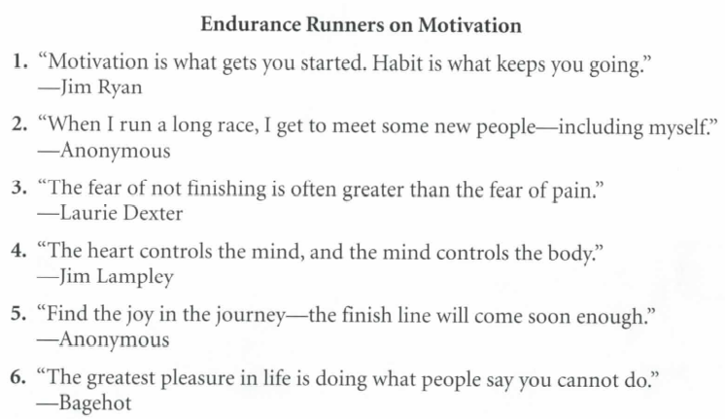
ACTIVITY E: ALTERNATIVE SPEAKING TOPICS
Discuss one of the topics. Use the vocabulary and grammar from the unit
- In Listening Two the professors talked about two motivations for endurance sports: the satisfaction of achieving goals and the closeness between athletes. Can you think of other reasons why extreme athletes do their sports?
- Research has shown that a large number of emergency room doctors do extreme sports. What do you think is the reason for this? Can you think of other professions that might match the personality of the extreme athlete?
ACTIVITY F: RESEARCH
Step 1: Choose an extreme sport from the box or think of your own.

bungee jumping | extreme skiing | ironman triathlon
cave diving | free-diving | kite boarding
class 5 river rafting | hang gliding | parasailing
cliff diving | ice climbing | rappelling
deep sea diving | Iditarod | sky diving

Step 2: Research the sport on the Internet or in the library. Find a picture of the sport and answer the question.
- What do you do in the sport?
- What is dangerous about this sport?
- Why do people like the sport?
- What other information can you find about this spo rt?

Step 3: Present your picture and information to the class

UNIT 4: SEPERATED BY THE SAME LAGUAGE
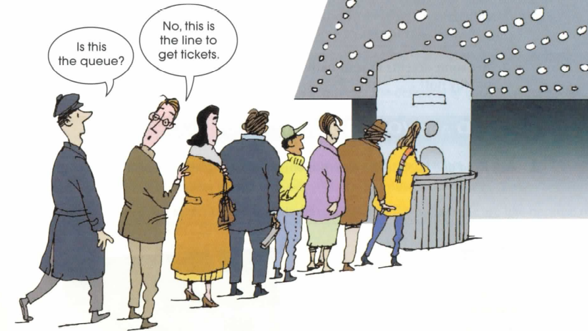
ACTIVITY A: PREDICT
Discuss the questions with the class.
- Look at the cartoon. Are the men talking about the same thing?
- 1n what country do people say queue? In what country do they say line?
- English novelist Sir Walter Besant (1836-1901) said: "England and America are two countries
separated by the same language." What did he mean?
ACTIVITY B: SHARE INFORMATION
Complete the activity in a small group
- When you hear a person speak in your native language, what can you tell from that person's accent?
Check () one or more items.

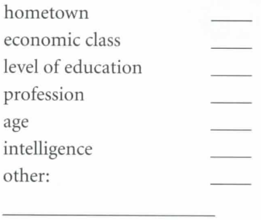
- Are some accents in your native language considered better than others? Why or why not?

ACTIVITY C: CREATE
This game of Truth or Dare' will help you review vocabulary from the unit and learn more about your classmates.
  - Play in a small group. Use a pair of dice or pieces of paper numbered 1-12. The players take turn choosing a number.
  - After choosing a number, the player looks at the corresponding number in the chart on page 64 and decides whether to "Tell the Truth" or "Take a Dare." If you choose "Take a Dare," use vocabulary from the box below.
Cross off the word after a player uses it. Each word may be used only once.
accept fit in with regional dialect aware of
get hungry up about self conscious code-switch
identity slang cross the line intentionally
standard dialect deal with it lay off
stereotype dialect make a big deal about
stick up for yourshelf

TELL THE TRUTH  Complete the task truthfully.  1. Describe something that you get hung up about.  2. Describe a time when someone made a big deal about something.  3. Describe a time you saw someone get stereotyped because of the way he or she spoke, looked, or acted.  4. Think of something that is an important part of your identity and describe why it is important.  5. Describe a time when you had to stick up for yourself or someone else in a difficult situation.  6. Describe a time when you had to tell someone to lay off  7. Describe something you have done to fit in with a group of friends.  8. Describe a time you saw someone act in a way that crossed the line.  9. Give an example of the slang you use with your friends.  10. Give an example of when you code-switch  between two dialects or languages.  11. Describe a problem you had and how you decided to deal with it.  12. Explain whether you have a standard or  regional dialect in your native language. | TAKE A DARE    Complete the task with a word or phrase from the vocabulary box on page 63.  - Give the definition of the word / phrase.  - Spell the word/ phrase without looking at it.  - Spell the word/ phrase backward without looking at it.  - Say another word / phrase that has a similar meaning.  - Say a word / phrase that has the opposite meaning of the word.  - Use the word/ phrase in a sentence about yourself.  - Use the word/ phrase in a sentence about someone else.  - Use some of the letters in the word/ phrase to spell a new word.  - Translate the word/ phrase into your native language.  - Without speaking, act out the meaning of the word / phrase.  - Make a question using the word / phrase.  - Say a sentence in the past tense using the word / phrase.

ACTIVITY D: FUNCTION
Leading a Small Group Discussion
- Look at the pictures of a classroom discussion. What is the teacher doing in each picture? Write the letter of
your answer in the blank.
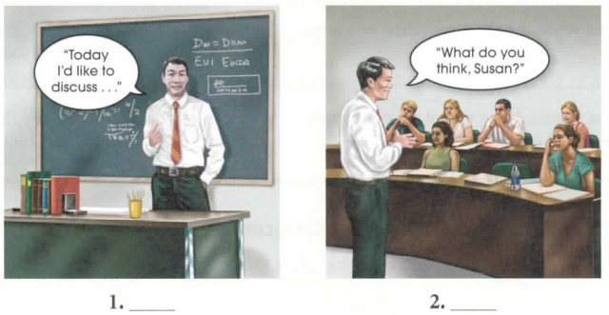
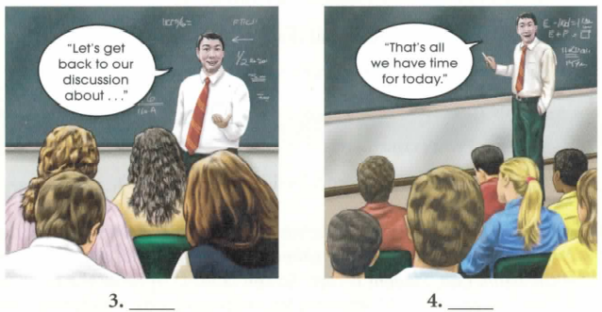
The teacher is ...
- beginning the discussion.
- keeping the discussion on topic
- ending the discussion.
- getting comments from different students.
In a group discussion, it i useful to have a leader to direct and control the conversation. The group leader must start and end the discussion, keep the discussion on topic, and make sure everyone has a chance to participate.
- Read the phrases that you can use to lead a discussion. With the class , think of other phrases that can be used
in each situation and write them in the blanks.
Starting a Discussion
  - Our topic for today is .. .
  - Today I'd li ke to discuss .. .
Getting Everyone to Speak
- Asking someone to talk
  - What do you think, (name)?
  - (name), do you agree?
- Asking someone to stop talking
  - That's a good point, (name). Can we hear from someone else?
  - I see your point, (name). Does anyone agree or disagree?

Staying on the Topic
  - Let' get back to our discussion about . . .
  - I'd like to return to the topic. What do you think about . . . ?

Ending a Discussion
  - That's all we have time for today.
  - So to sum up . . . (You summarize the ideas expressed in the discussion.)
- Work in a group of four. Discuss how to improve your pronunciation in English. Use the conversation guide below.
One student (Leader) leads the discussion. The other three students (Students 1, 2, and 3) discuss the topic.
Use ideas from the box or make up your own. Repeat the activity so that each group member plays all
the ports.
LEADER: (Start discussion) the best way to improve your pronunciation when you speak English. (Ask Student l to talk)
?
STUDENT 1: I think that is the best way. For me it's good because _
LEADER:(Ask Student 2 to talk) ?
STUDENT 2: I don't like because .I think the best way to improve your pronunciation is _ That's because .For example,

LEADER: (Ask Student 2 to stop talking and Student 3 to talk)

STUDENT 3: I think____________ because ________________
LEADER: (End discussion) _____________________
ACTIVITY E: PRODUCTION – LEADING A SMALL GROUP DISCUSSION
In this activity, you will each lead a small group discussion related to language . Try to use the vocabulary, grammar, pronunciation, and discussion-leading skills that you learned in the unit.
Work in a group of four. Follow the steps.
Step 1: Each student chooses a different situation from the list.

Situation 1
Mike is a TV news reporter from the state of Mississippi. He is applying for a job as a reporter on a national news program that will be seen all over the United States. Mike speaks with a southern accent, not the standard American accent of many other reporters. Mike is worried that he will not get the job because of his accent. What should Mike do?
Situation 2
Julia is a high school student. She grew up in Mexico and just moved to Spain. She feels self-conscious at school because her accent is different. She wants to fit in but she feels silly speaking with a Spanish accent because it doesn't feel natural. What should Julia do?
Situation 3
Angelique work as a salesperson in a French clothing store in Australia. She speaks fluent English with a French accent. Her boss likes the way he speaks. He thinks her accent helps sell clothing. Her friends like the way she speaks. They say her accent makes her different and special. Angelique has recently become an Australian citizen. She thinks she should change her accent to sound more Australian. What should Angelique do?
Situation 4
Sharon works for a financial company in a small city in Ireland. She recently hired Meir from India, who speaks an Indian dialect of English. Sharon is happy with Meir's work. However, there are problems between Meir and some people on her staff. These people are frustrated because they have a difficult time understanding Meir because of his accent. What should Sharon do?
Step 2: Beginning with the student who chose Situation 1, take turns leading a group discussion about the situation you chose. The leader should make sure that every person participates.
In each discussion:
    - Talk about possible solution for the situation (what the person could do).
    - Decide which solution is best (what the person should do).
Step 3: Tell the class about the solution your group chose for each situation.
ACTIVITY F: ALTERNATIVE SPEAKING TOPICS
Discuss one of the topics. Use the vocabulary and grammar from t he unit.
1. Many governments have laws about which languages people can use. For example, some countries have one or more "official languages" that must be taught in school and spoken at work and in the government. Some countries do not allow certain languages to be spoken at a U. What is the language policy in your country? Which language or dialects are accepted? Which are not accepted? Why?
2. English has been described as a "world language. " Many people all over the world speak English at school, in business, in politics, and in other situations. What are the advantage of having a world language? What are the disadvantages? What other languages do you think might become world languages in the future? Why?
ACTIVITY G: RESEARCH
Step 1: Choose a group of people who have their own slang (teenagers, musicians, college students ) or jargon (computer programmers , medical professionals).
Step 2: Interview a person from that group and take notes. A k the person to tell you about special slang or jargon the group uses. Then ask him or her to explain the meaning of five words or phrases. You can also find dictionaries of slang words on the Internet (keywords = slang and jargon ) or in the library to add to your research.
Step 3: Report to the class. Tell them what group of people you researched. Then write the slang or jargon on the board ( but not the definitions ). See if your classmate can guess the meaning of the word.

UNIT 5: CULTURE AND COMMERCE
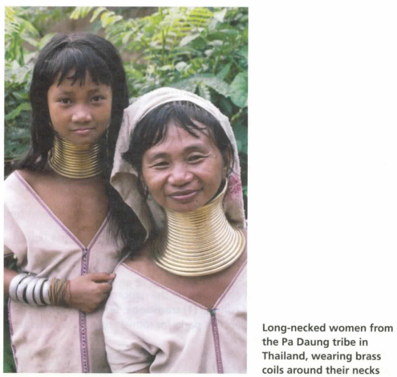
ACTIVITY A: PREDICT
Discuss the questions with the class
1. Look at the photo. Why do you think these women are wearing coils around their necks?
- Read the title of the unit. Commerce means business. In your opinion, what is the relationship between culture and commerce in tourism?
ACTIVITY B: SHARE INFORMATION
Work in a small group. First, read each statement and decide your opinion. Write SD (strongly disagree), D (disagree), A (agree), or SA (strongly agree) in each blank. Then discuss your opinions with the group.
- Tourism can be harmful to people living in a tourist community.
- Tourism can help people have a better life.
- Tourist activities that harm people or the environment should not be allowed.
- Any tourist activity that makes money should be allowed.
- Tourism is a good way for people to make money.
- Tourism destroys the natural environment.

ACTIVITY C: CREATE
Work in a small group. Each person thinks of a tourist destination he or she has visited. Take turns making a short presentation about the destination. Answer the questions in your presentation. Use the vocabulary from the box.
- What tourist destination did you visit?
- What are the major tourist attractions?
- What impact does tourism have on the locals?
- What impact does tourism have on the environment?
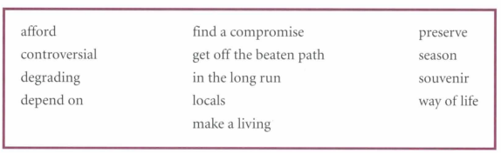
ACTIVITY D: PRODUCTION
In this activity, you will participate in a simulation-an activity that reflects a real-life situation.
In this simulation about the effects of tourism, you will talk about a controversial proposal to build a hotel in a rainforest. You will need to negotiate your ideas and reach a compromise. Try to use the vocabulary, grammar, pronunciation , and language for making suggestions that you learned in the unit.
Read the situation about a company that wants to build a hotel. Then complete the activity.
Royal Hotel wants to build a large 300-room resort hotel on Coral Beach, a quiet beach next to a small fishing village. Coral Beach only ha a few tourist now, but the company has studied the area and thinks it can be a popular tourist attraction. Tourists can:
- enjoy the beautiful beaches
- visit the local fishing village
- explore the nearby rainforest
The proposal is controversial. In order to build the resort, Royal Hotel would need to build a road through the rainforest. The rainforest is a protected area that is managed by Landwatch, an environmental group. Landwatch is worried about the impact the hotel will have on the environment and wildlife. In addition, local residents in the fishing village are worried about the negative impact on their way of life.
Step 1: Work in three groups. Group A takes the point of view of representative of Roya l Hotels, Group B takes the point of view of the Land watch group, and Group C takes the point of view of the local villagers. Read your group's position below and on page 90. Do not read other groups' positions. Talk about the positive and negative impacts of the hotel. Take notes.
Group A: Royal Hotels
Your group represent the needs and wants of tourists visiting the area.
  - In order to build the hotel, Royal Hotel need permission from Landwatch to build a road through the rainforest.
  - The hotel needs worker in the hotel (restaurants, hop, etc.) and to run tourist services such as area and fishing tour.
  - In a hotel survey, tourists said they want to:
- visit natural areas like the ocean and the jungle, and see wildlife
- go to nice, clean beaches
- eat at good restaurants
- see life in a traditional fishing village
- go sport fishing
- Royal Hotels is willing to spend one million dollars to preserve natural areas and/or help the fishing village.
Group B: Landwatch
Your group represents the needs of the environment: the protection of the animals, sea life, plants, land, water, and air.
    - Because the population is small, the area has very little pollution.
    - Some villagers make money by hunting wild animals in the rainforest and selling them to restaurants in other cities. Landwatch wants to preserve the wildlife. It wants local to stop hunting the animals, but the locals need the extra money.
    - The fishermen have taken too many fish from the ocean. Landwatch wants them to catch fewer fish and let the fish population grow again.
    - Landwatch needs money to continue it rainforest research and to teach the locals how to preserve the environment.
Group C: Locals
Your group represent the needs of local resident.
    - People in the village Jive a traditional way of life. The culture is based on their lives as fishermen, with many rituals, crafts, and customs. Some people are afraid these traditions will be lo t if the village changes.
    - The fishermen use the Coral Beach to bring in their fishing boats.
    - There is a high unemployment rate in the village. There are fewer fish in the ocean now, so there is less work for the fishermen. There are not many other job for people in the village.
    - The village is not well developed. It needs better roads and utilities (water, electricity, phones). The nearest hospital is a three-hour drive, and most villagers don't have car. There is a small school, but it needs more teachers and supplies (textbooks, paper, pencils, etc.).
    - Some villagers earn extra money by hunting wild animals in the rain forest and selling them to restaurants in the city. Landwatch is trying to stop people from doing this, but the locals need the extra money.

Step 2: Form new groups of three, one student from Group A, one from Group B, and one from Group C. Each student explains the point of view of the group he or she is representing, (for example, "I represent Royal Hotels and we think ... "). Work together to find a compromise proposal. Take notes in the chart.
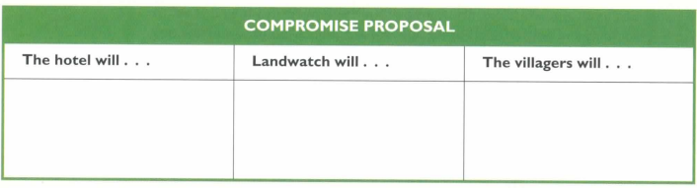
Step 3: Present the compromise proposals to the whole class.
ACTIVITY E: ALTERNATIVE SPEAKING TOPICS
Discuss one of the topics. Use the vocabulary and grammar from the unit.
- If you were a travel agent in Thailand, would you book tours to see the long­ necked women? Why or why not?
- For some countries, tourism is the most important way for the country to make money. For example, Thailand used to make most of its money from growing rice, but now more money come from tourism. What are the pros and cons
of this?
ACTIVITY F: RESEARCH
Some tourists use their vacation time to help others or help the environment. For example, a volunteer could go to Tanzania and build homes for poor people. These types of vacations are called "service vacations" or "volunteer vacations."
Step 1: Do research to find an example of a service vacation. You can ...
- look for service vacations or volunteer vacations on the Internet.
- look for brochures or magazines about service vacations from environmental groups (for example, EarthWatch) or human aid groups (for example, Global Volunteers).
Step 2: Prepare a short report to share with the class. Use the questions to guide your research.
- What is the destination of this vacation?
- What can you do on this vacation?
- Can people who choose this vacation really help the environment or the people who live nearby? If so, how? If not, why not?
- Would you go on this vacation? Why or why not?
Step 3: Present your report to the class.

UNIT 6: THE ART OF STORYTELLING

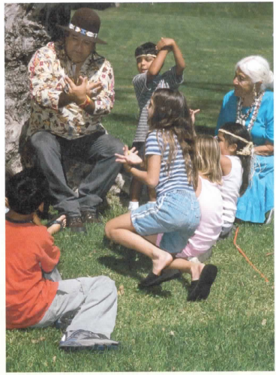
ACTIVITY A: PREDICT
Discuss the questions with the class.
- What's happening in the photo?
- Read the title of the unit. Why is storytelling an art? How is it similar to the art of painting or dancing?
ACTIVITY B: SHARE INFORMATION
People have told stories for thousands of years as a form of entertainment. Today we can also read stories in books or watch them in movies or on TV.
Discuss the questions with a partner.
- Did anyone tell you stories when you were a child? Who told the stories? What kind of stories did you hear?
- What do you like about different kind of storytelling? Which types do you like best? Why?
- listening to someone tell a story
- reading a book
- seeing a movie
- watching a play
ACTIVITY C: CREATE
Work with a partner. Choose three words from the lists. Each word should come from a different box. Create a short conversation that uses all three words.
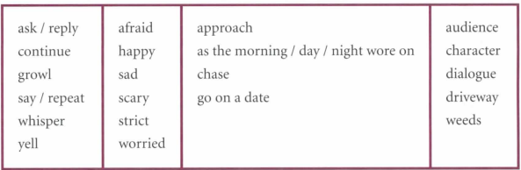
Example
STUDENT A: Is this your house?
STUDENT B: Shhh. You need to whisper. My parents are really strict. STUDENT A: So you don't want them to know that we went on a date? STUDENT B: Right!
Perform your conversation for the class. The audience listens and identifies the three words you chose. Then repeat the activity with three different words.
ACTIVITY D: PRODUCTION
- Work with a partner. Look at the pictures to retell the story of "Lavender." Take turns telling the story. Use the suggested vocabulary if you like. Use transition words.
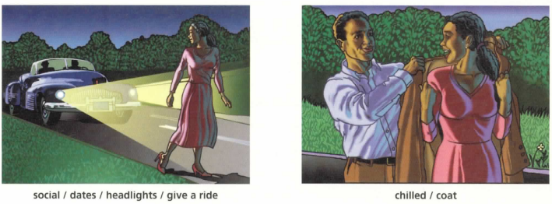

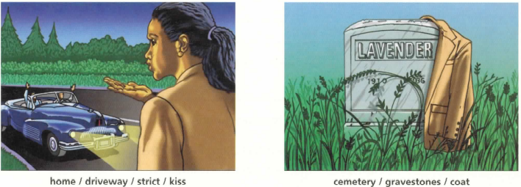
- In this activity, you will prepare a story and tell it to the class. The story could be from your culture or one that you make up yourself. Try to use the vocabulary, grammar, pronunciation, and transitions you learned in the unit.
Follow the steps.
Step 1: Think of a short story that will be interesting and entertaining for your audience. It could be exciting, scary, funny, or sad. It could have unexpected events or a moral, or it could have unusual characters.
Write an outline of your story on a piece of paper. Use the sample outline as a guide.
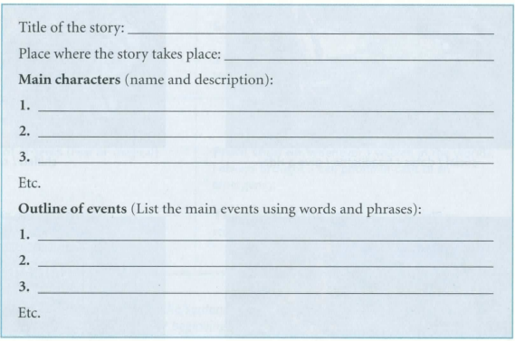
Step 2: Use your outline to practice your story. Use the storytelling techniques discussed in this unit.
- Use your voice (loud I soft, high / low) to create feelings.
- Use dialogue to bring your characters to life.
After you have practiced on your own, meet with a partner and tell your story. Switch partners and tell your story again.
Step 3: Perform your story for the class. Be dramatic and have fun.
ACTIVITY E: ALTERNATIVE SPEAKING TOPICS
Discuss one of the topics. Use the vocabulary and grammar from the unit.
- Today, most stories are told through book and movies rather than through oral storytelling. What will people lo e if the tradition of oral storytelling end? What are the advantages and disadvantages of modern storytelling through book and movies?
- There are some stories that are very similar from one culture to another. For example, almost every country in the world has a version of "Cinderella”, a story about a poor girl who marries a prince. What do you think is the reason for this?
ACTIVITY F: RESEARCH
Step 1: Find a recorded story at the library or on the Internet, or ask a friend or relative to tell you a story. Listen to the story. (If you can't find a story in English, listen to one in your native language.)
Step 2: Prepare a summary of the story using the questions.
- What is the name of the story?
- Who told the story?
- Who are the main characters? Give a one-sentence description of each character.
- What happens in the story? Give a brief summary of the plot.
- Do you like this story? Why or why not?
Step 3: Present your summary to the class, or make a recording of your summary and give it to your teacher.

UNIT 7: VOLUNTARY SIMPLICITY
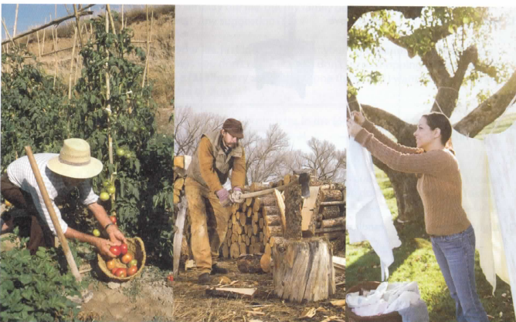
ACTIVITY A: PREDICT
Voluntary simplicity means choosing to live a simple life. Look at the pictures and discuss the questions with the class.
- What are the people in the pictures doing to live simply?
- Why do you think people choose to live simply?

ACTIVITY B: SHARE INFORMATION
Work in a small group. Look at the two ways of doing things and discuss the questions.
Which in each pair ...
- costs less?
- is easier to use?
- is better for the environment?
- do most people in your country use?
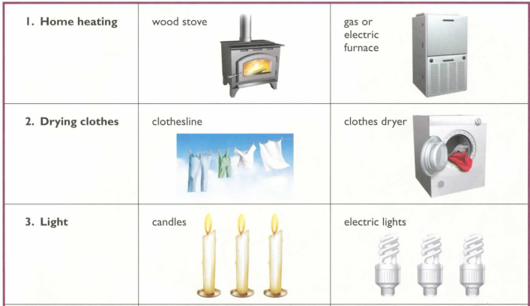
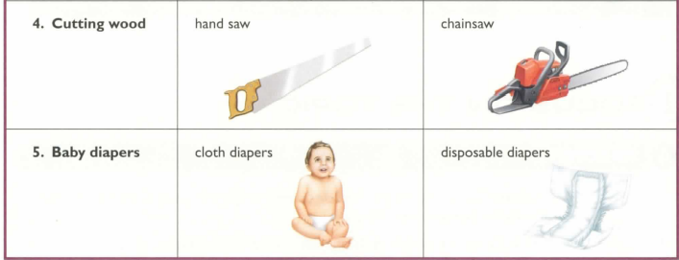
ACTIVITY C: CREATE
An analogy shows relationships between words. Below are four types of analogies that show different types of relationships.
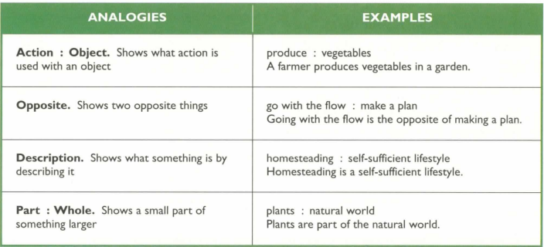
Work with a partner. Make analogies for the words from the box. Try to make as many types of analogies as you can. You can use words more than once.
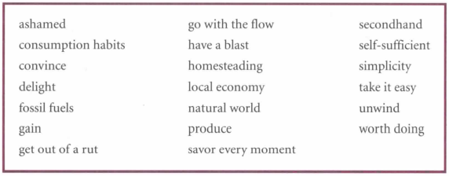
ACTIVITY D: PRODUCTION
- Work in a group of three or four. Choose one of the following simple pleasures, or think of one of your own. Student A makes a statement about the activity. Student B repeats the statement and adds more description. Student C repeats Student B's statement and adds more description. Continue until
everyone has taken a turn.

Example
STUDENT A: I like sitting on the beach.
STUDENT B: I like sitting on the beach near my house.
STUDENT C: I like sitting on the beach near my house and listening to the crashing waves.
STUDENT D: I like sitting on the beach near my house, listening to the crashing waves, and feeling the warm and under my feet.
Simple Pleasures
- hiking
- reading
- spending time with friends
- eating a good meal
- working in the garden
- playing (musical instrument)
- your idea: _ _ _ _ _ _ _ _ _ _ _ _ _ _ _ _ _ _ _ _ _ _ _ _ _

Choose another simple pleasure and repeat the activity.
- Improtu Presentation
Impromptu presentations are talks that you give without much preparation. Making an impromptu presentation will challenge you to think quickly and will also give you practice talking in front of a
group. In this activity, you will make an impromptu presentation about simple pleasures. Try to
use the vocabulary, grammar, pronunciation, and descriptive language that you learned in the unit.

Work in a group of five. Follow the steps.
Step 1: Look at the five categories of simple pleasures. Brainstorm a list of activities. Each student should suggest one activity he or she enjoys for each category. Take note.
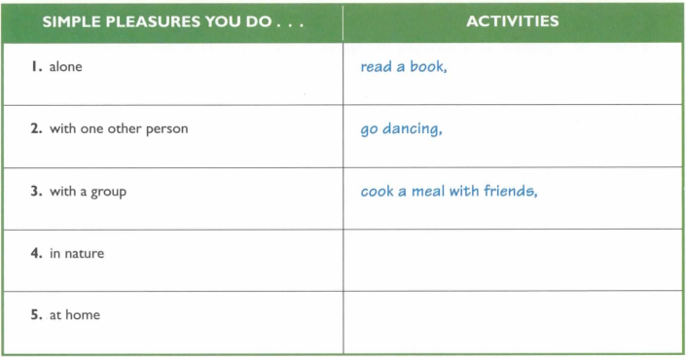

Step 2: Write each of the five categories on separate pieces of paper. Put the papers into a container. Each group member pick a piece of paper from the container. Look at the category you picked and choose one activity you listed in the chart for that category. Then each student take four minutes to prepare a presentation on the activity. Use the outline as a guide.
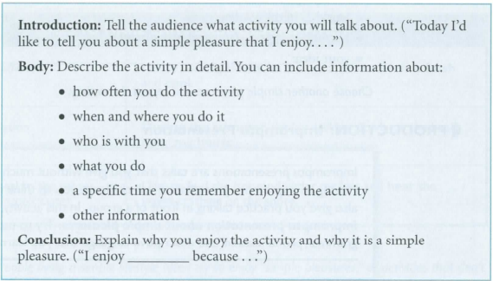
Step 3: Meet in your group. Take turns giving your presentation.
ACTIVITY E: ALTERNATIVE SPEAKING TOPICS
Discuss one of the topics. Use the vocabulary and grammar from the unit.
- Have you heard of anyone who has chosen to live a simple life? What has this person done to simplify his or her life? Why has he or she made this choice?
- What are the advantages and disadvantages of living a self-sufficient lifestyle? What makes this lifestyle easier? What makes it harder?

ACTIVITY F: RESEARCH
Simple living is an idea that has become popular in many western countries. Many people are tired of their fast-paced way of life and want to make a change.
Step 1: Choose one of the topics from the box or think of your own.

affluenza organic farming take back your time
clutter free simplicity circle un-jobbing
co-housing slow food voluntary simplicity
Step 2: Research the topic on the Internet or in the li brary. Use the questions to guide your research.
- What is ?

- Why are people interested in ?

- How does ______________ fit in with the goals of the simple living lifestyle?
Step 3: Present your findings to the class.

UNIT 8: BEFORE YOU SAY “I DO”
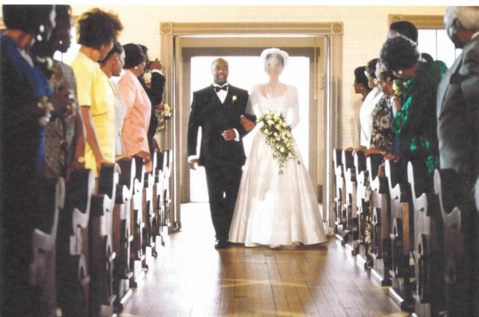
ACTIVITY A: PREDICT
Discuss the questions with the class.
- What's happening in the picture?
- Look at the title of the unit. What happens before you say "I do"? What do you think this unit will be about?

ACTIVITY B: SHARE INFORMATION
Work in a small group. Read the quotations about marriage. After each quotation is a sentence that summarizes it Circle the best answer to complete each statement.
- "In almost every marriage, there is a selfish and an unselfish partner. A pattern begins and never changes, of one person always asking for something and the other person always giving something away."
-Adapted from Iris Murdoch, British writer and philosopher (1919-1999)

In most marriages, can get what he or she wants.
  - only one person
  - both the husband and wife
  - neither the husband nor the wife (no one)
- "A man who is a good friend is likely to find a good wife because marriage is based on a talent for friendship."
-Adapted from Friedrich Nietzsche, German philosopher (1844-1900)
To have a happy marriage, a man must .
- have a good friend
- be a good friend to his wife
- be sure his wife has a good friend
- "Keep your eyes wide open before marriage, and half shut afterwards."
-Benjamin Franklin, American statesman and philosopher ( 1701-1790)
Choose your husband or wife carefully, but
  - ignore your spouse's' mistakes
  - try to change your spouse
  - don't look at your spouse
Discuss the quotations with the class. Do you agree or disagree with the writers? Why or why not?
ACTIVITY C: CREATE
- Choose a situation from the list. As a group, create a role play about the situation. In your role play, use the four vocabulary words you picked.
Situations
  - Parents and other family members are talking to their son or daughter about his or her plans for marriage.
  - Friends are discussing what kind of spouse they want.
  - A couple is discussing their roles in their relationship (who will earn money, take care of children, cook, clean, etc.).
  - Family member are talking about a couple that is breaking up or getting a divorce.
[Make up a situation]
- Practice the role play and then perform it for the class.

As you watch the role plays by the other groups, listen carefully for the four vocabulary words they use.
Write them down. When the role play is finished, check to see if your words match the pieces of paper that the performers picked.
ACTIVITY D: PRODUCTION
- Work in a small group. Discuss the following topic: "Is it better to be married or single? Why?" Use the adjectives from the box and add your own
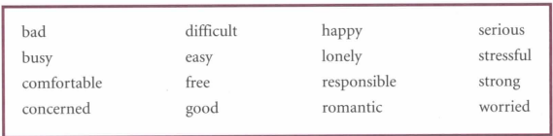
Example
STUDENT A: I think it's more difficult to be single than to be married. If you're single, you're always looking for someone.
STUDENT B: That's true. I think married people aren't as lonely as single people.
STUDENT C: Not necessarily....
- In this activity, you will give a 3-5-minute presentation on a controversial topic related to marriage.
Try to use the vocabulary, grammar, pronunciation, and transitions for introducing main ideas and supporting points that you learned in the unit.

Follow the steps.
Step 1: Choose a topic for your presentation. You may choose one of the following topics or think of your own topic.
- living together before marriage
- the rights of unmarried couples
- using dating services to find a spouse (Internet sites, personal ads, speed dating)
- arranged marriages vs. love marriages
- mixed marriages (religion, age, language, culture, race)
- types of families (blended1, single parent)
- living situations in marriage (long-distance marriages , living with relatives )
- divorce
- Other:
Write a sentence stating your opinion about the topic:
Example
Topic: Prenuptial Agreements
Opinion: I think prenuptial agreements are a good way to prepare for marriage.
Step 2: Plan your presentation using the outline. Practice giving your presentation to a friend or in front of a mirror.
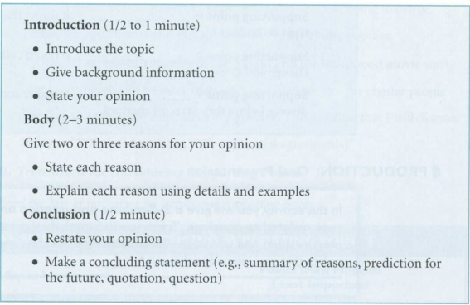
Step 3: Give your presentation to the class. When presenting, look at the audience and use your outline as a guide. Speak loudly and clearly.
ACTIVITY E: ALTERNATIVE TOPICS
Look at the graph and discuss the topics. Use the vocabulary and grammar from
the unit.
What Makes a Marriage Work?
Percent saying each is very important for a successful marriage
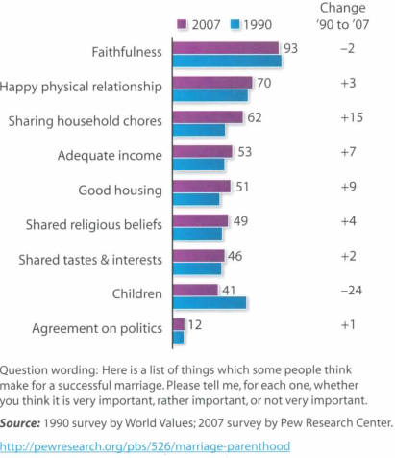
- According to the survey, what do Americans feel is most important for a successful marriage? What is least important?
- How do you think people in your country would answer the questions?
- In your opinion, what two things listed on the chart are most important for a successful marriage? What two are least important?
ACTIVITY F: RESEARCH
Step 1: In this activity, you will research an alternative marriage practice. Choose one of the topics from the box or think of your own.
civil unions
dowry
mail-order/ Internet brides
matchmaker
polygamy
serial monogamy
Step 2: Research the topic on the Internet or in the library. Use the questions to guide your research.
- What is / are ,
- In what culture might you find ?

- Would be legal in your culture? Why or why not?
- What do you think about ? Why do you feel this way?
Step 3: Meet in small groups with students who chose different marriage practices. Present the results of your research and have a discussion.

UNIT 9: PERSONAL CARBON FOOTPRINT

ACTIVITY A: PREDICT
Look at the picture and discuss the questions with the class.
- Carbon dioxide (CO2) gas is made by burning fuel such as gasoline, diesel, oil, coal, or wood. What do you think are the effects of too much CO2 in the air?
- What do you think a personal carbon footprint is?
ACTIVITY B: SHARE INFORMATION
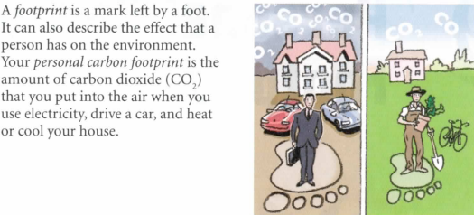
Discuss your answers in a small group. How large is your personal carbon foot print? Are you surprised? Why or why not?
ACTIVITY C: PRODUCTION
- Work in a small group. Discuss the question for four minutes. Each person should interrupt at least once to share an idea or opinion, ask a question, or ask someone to repeat. Each person should also hold the floor at least once if he or she is interrupted.
Use the strategies listed on the book (pages 166 and 16 7).
What can individual, government, and industry do to reduce carbon emissions?
- Participating in a Seminar
In a seminar, there is usually a small group of students with a leader. The leader presents information to the group and leads a discussion. In this activity, each student will take turns being the leader and the other students will participate in the discussion. Try to use the vocabulary, grammar, pronunciation, and strategies for interrupting politely and holding the floor that you learned in the unit.
Work in a group of four or five. Follow the steps.
Step 1: Choose a seminar topic. Each group member should choose a different topic. Topic 1: global CO2 emissions (Figures 1-2, page 169; discussion questions, page 190)
Topic 2: transportation (Figure 3, page 169; discussion questions, page 190)
Topic 3: CO, emissions and food production (Figure 4, page 170; discussion questions, page 191)
Topic 4: natural disasters and global warming (Figure 5, page 171; discussion questions, page 191)
Topic 5: sea level rise and global warming (Figure 6, page 172; discussion questions, page 191)
Step 2: Prepare for the seminar. You will become the expert on your topic.
- Study the information about your topic. Look at the figure and the discussion questions for your topic only. Make sure you understand all of the vocabulary.
- Think of an additional discussion question.
You can also work with students from other groups who have the same topic.
Step 3: With your seminar group, take turns leading a discussion on your topic using the discussion question . Make sure to refer to your figure during the discussion.
Topic I: Global CO Emissions
2
A country's carbon dioxide emission can be measured in two ways: the total amount of CO2 produced by the whole country (figure 1) or the amount of CO2 produced by each person (figure 2).
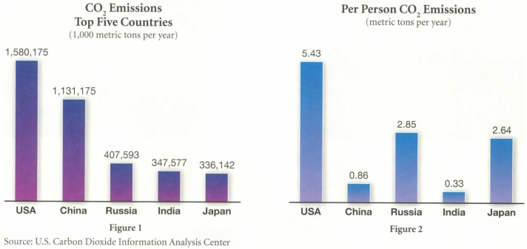

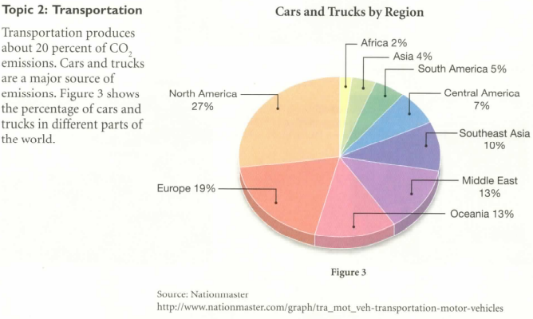
Topic 3: CO Emissions and Food Production
2
The process of growing, preparing, and selling food creates CO₂ emissions. Figure 4 shows exam pies of
the emissions produced to make a box of breakfast cereal.
CO Emissions from Producing Breakfast Cereal
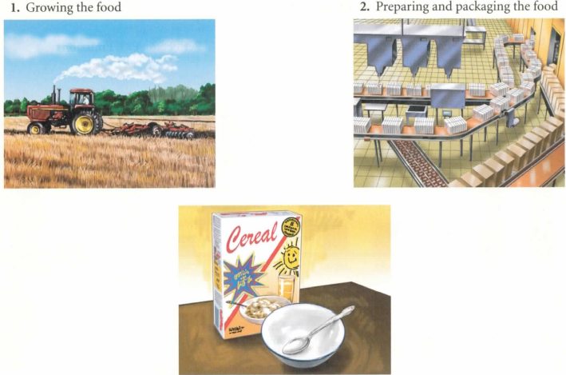
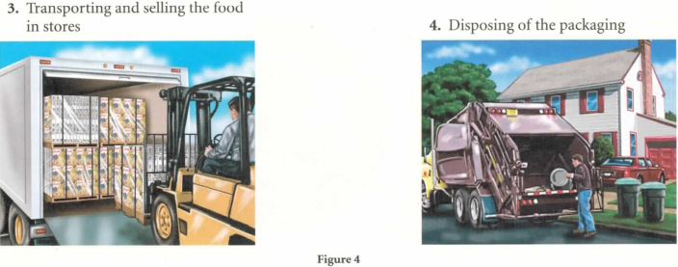
Topic 4: Natural Disasters and Global Warming
Figure 5 shows the rise in weather-related disasters compared to earthquakes, which are not related to the weather.

Rise of Weather-Related Disasters Compared to Earthquakes
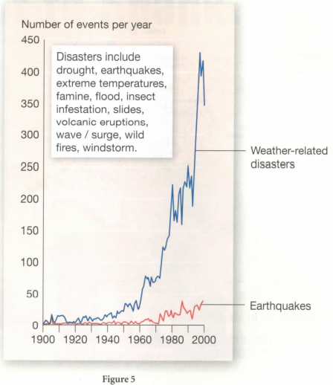
Source: "Trends in natural di a ter ." UNEP/GRID-Arenda/ Maps and Graphics Library. 2005. UNEP/GRlD-Arendal. 28 Sep 2007 <http:// maps.grida.no/go/grap hic/tr ends-in-natura l-di a ter s>. E111mnn11elle Bo11may, Cartographer. UNEPIGRID-Arendal
Topic 5: Sea Level Rise and Global Warming
Global warming may cause ice in the North and South Poles to melt. The melted ice will cause sea levels to rise. The red areas show places that will be underwater after six-meter (19.7-foot) sea level rise.
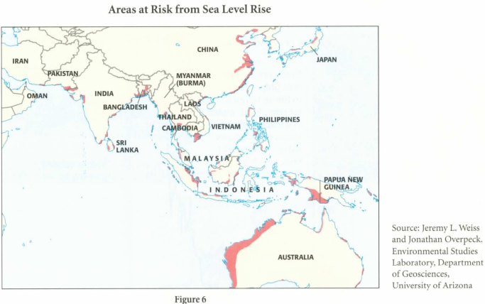
Other places affected by six-meter rise:
Amsterdam, the Netherlands London, England New York, United States Lagos, Nigeria Miami, United States Vancouver, Canada
ACTIVITY D: ALTERNATIVE SPEAKING TOPICS
Discuss one of the topics. Use the vocabulary and grammar from the unit.
l. How has global warming affected you or your community? Have you seen any effects of global warming? What are people doing to reduce carbon emissions? Explain.
2. What lifestyle changes could you make to reduce your own carbon footprint?
ACTIVITY E: RESEARCH
There are many services and technologies that can help lower carbon emissions, including:
- Transportation: car sharing services (for example, Zip Car, I-GO ), hybrid electric cars, biofuel, bicycle sharing programs
- Electrical use: Energy Star appliances, compact fluorescent light bulbs, wind power, solar power, hydropower
- Heating and cooling: green buildings, solar heat, eco-roofs, insulation, geothermal
- Business and industry: tree planting programs, CO₂ emissions trading, green product design
Step 1: Do research on the Internet about a service or technology that reduces carbon emissions. Find out how it works, how much it costs, and how it reduces carbon emissions.
Step 2: Share your research in a small group or with the class.

UNIT 10: TO SPANK OR NOT TO SPANK?
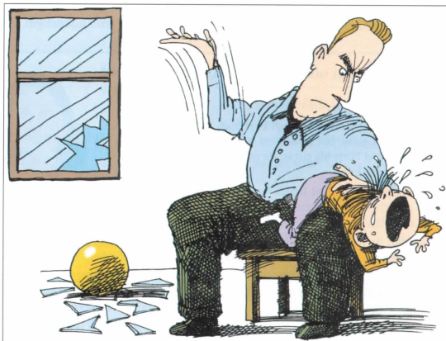
ACTIVITY A: PREDICT
Discuss the questions with the class.
- Look at the picture. Why do you think the parent is spanking the child? What did the child do? Do you think corporal punishment is a good punishment in this case?
- Read the title of tl1e w1it. What do you think this unit will be about?

ACTIVITY B: SHARE INFORMATION
Discuss the questions in a small group. Then shore your ideas with the class.
- How did your parents punish you when you were a child? How did you feel about the punishment then? How do you feel about it now?
- As a child, how did you learn right from wrong?

ACTIVITY C: CREATE
Divide into two groups, A and B.
First, Group A students conduct Survey A. Ask three students all of the questions.
Group B students answer the questions and give reasons, using the words from the box in their answers.
Then Group B students conduct Survey B.
SURVEY A | ANSWERS
 | Student 1 | Student 2 | Student 3
1. Is it important for parents and children to have give and take when they discuss problems? Why or why not?
2. When children misbehave, should they help to decide the consequences? Why or why not?
3. Is there a fine line between discipline and child abuse? Why or why not?

SURVEY B | ANSWERS
 | Student 1 | Student 2 | Student 3
1. Do you think that, by and large, most parents support or oppose spanking? Why or why not?
2. Does the government have the right to control how parents raise their children? Why or why not?
3. Should countries take a hard line and make spanking illegal? Why or why not?

acceptable | debate | legal | punish
arrest | draw the line | limits | respect
black-and-white issue | get carried away | permissive | short-term
the bottom line | the law | problem solving | violent

ACTIVITY D: PRODUCTION – DEBATE
In this activity, you will debate a topic related to punishment. In a debate, two teams discuss different sides of the same topic. One team is pro (for) a position on the topic. The other team is con (against) the position. Try to use the vocabulary, grammar, pronunciation, and language for expressing confidence that you learned in the unit.
Work in two teams. Follow the steps. (If you have a large class, you may divide into groups and have several debates on different topics.)
Step 1: Read the topics and the background information that follows each topic.
Choose one topic to debate. Decide which team will be pro and which will be con.
- Teenagers should be punished as adults.
In the United States, children and teenagers under age 18 who commit crimes are punished differently from adult criminals. They go to special jails, have shorter jail sentences, and cannot get the death penalty. In some states, courts are punishing children and teenagers like adults.
- Teachers should be able to use spanking to discipline their students.
In some countries, teacher can hit or spank their students when the students misbehave. In other countries, it i against the law for teachers to hit their students.
- Governments should use corporal punishment to punish criminals.
In some countries, the government uses corporal punishment (hitting or beating) to punish criminals. In other countries, the government can't use corporal punishment.
- Parents should be punished when their children do something wrong.
In the United States, some people want to pass a new law that says if a child under 18 does something wrong (such as stealing from a store or missing school), the parents will be punished because they did not control their child.
Step 2: Work with your team to prepare for the debate:
- Plan your arguments (points to support your position). Write an outline.
Example

Your team's position: Parents SHOULD NOT be allowed to spank their children.
Argument 1: Spanking isn't effective.
Explanation: - It only stops behavior in the short term.
- It doesn't teach kids to solve their problems.
- Think about the arguments the other team may make. Plan your counter­ arguments (points you can use against the other team's arguments). Write an outline.
Example

Other team's position: Parents SHOULD be allowed to spank their children.
Possible argument: Spanking has been used for thousands of years as a type of discipline.
Counterargument: Today we understand more about psychology and how spanking affects children.
Step 3: Debate the topic. The two teams take turns presenting their arguments and counterarguments. Team members should take turns presenting the information.

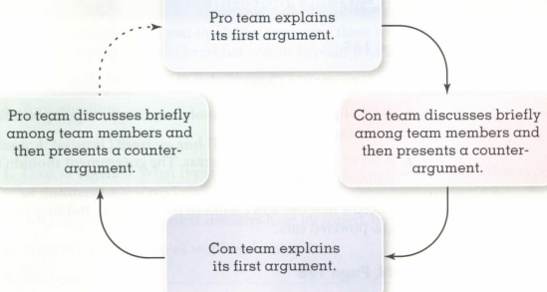
ACTIVITY E: ALTERNATIVE SPEAKING TOPICS
Read the quotes about punishment. Do you agree with them? Why or why not? Share your thoughts with the class.
- Quote: "Spare the rod and poi] the child."
-Samuel Butler, poet
Paraphrase: If you don't spank your children, they will be spoiled.
- Quote: "The test of the morality of a society i what it does for it child ren." - Dietrich Bonhoffer, German pa tor, Nazi resister
-Paraphrase: A good society treats its children well.
- Quote: "My mother had a great deal of trouble with me, but I think she enjoyed it." - Mark Twain, author
Paraphrase: I caused my mother a lot of trouble, but I think she enjoyed raising me.
ACTIVITY E: RESEARCH
Step 1: Visit a place where you can see adults taking care of young children. For example, a nursery school or preschool, a playground, or a friend or relative who has children. Watch the children and adults for an hour or so. Look for times when a child misbehaves and an adult disciplines the child. Use the chart P.197 to take notes about what you see.

Here are some things an adult may do to discipline a child (also look for other things that are not on this list):
- Say "No" to the child
- Take something away from the child
- Move the child to a different place
- Make the child it by himself or herself
- Hold the child so he or she can't do something
- Yell at the child in a loud voice
- Hit or spank the child
Step 2: Write a report on what you observed. Use the questions to guide you.
- What types of discipline did you see? Was the discipline violent or nonviolent?
- Did the discipline make the child top misbehaving? Why or why not?
- What does this type of discipline teach a child?
- How was the discipline the same or different from other type of discipline you have been or experienced?
Step 3: Share your research in a small group or with the class.

