**TOPIC: A WORLD OF FRIENDS**



**I. FOCUS ON THE TOPIC**

1. Read the title of the unit. What does it mean?

2. Look at the photo. Are the people friends or family? Where are they?

3. Do you have friends from other countries? How did you meet them?

**II. VOCABULARY**

**1. Look at the list of countries. Is there a Friendship Force club in your country?**



A Friendship Force visitor from the U.S. with her host family in Norway

**Friendship Force Member Countries**

|  |  |  |  |  |
| --- | --- | --- | --- | --- |
| Australia | Costa Rica | India | Nepal | Slovakia |
| Austria | Croatia | Indonesia | Netherlands | South Africa |
| Azerbaijan | Cyprus | Israel | New Caledonia | Sweden |
| Belarus | Czech Republic | Italy | New Zealand | Taiwan (ROC) |
| Belgium | Egypt | Japan | Norway | Tanzania |
| Bosnia and Herzegovina | Estonia | Jordan | Peru | Thailand |
| Brazil | France | Kenya | Philippines | Turkey |
| Burundi | Georgia | Korea | Poland | Ukraine |
| Canada | Germany | Latvia | Romania | United Kingdom |
| Cayman Islands | Ghana | Mexico | Russia | United States |
| Chile | Hungary | Mongolia | Singapore | Vietnam |
| Colombia |  |  |  |  |

**2. Read the text**

**“A World of Friends Is a World of Peace”**

And now, a message from the Friendship Force. The Friendship Force says, “A World of friends is a world of peace.”

The Friendship Force is an **international** friendship organization. Friendship Force groups **travel** to **foreign** countries. In the new country, the Friendship Force visitors **stay** with **host families**. They learn about their host family’s life and **culture**. The visitors and their host families **spend** a lot of **time** together and they become good friends.

Every year, Friendship Force visitors make 40,000 new friends in 56 different countries. This is important because when people make international friends, they help to make peace in the world.

Are you interested in the Friendship Force? Please go to our website for more information. If you want to travel with Friendship Force, send us an application so we can learn more about you. And remember, “a world of friends is a world of peace.”

**3. Circle the correct answer to complete the sentence**

The Friendship Force says, “When you have friends in foreign countries, _____”

1. you held to bring peace to the world
2. you can be in the Friendship Force

**4. Match the boldfaced words on the left with the definitions on the right. Write the letter of the correct definition on the line**.

|  |  |  |
| --- | --- | --- |
| ______ | 1. The Friendship Force goes to 56 different countries. It is an international organization. | a. get to know new people |
| ______ | 2. Friendship Force visitors travel to many different countries. | b. a page with information about yourself |
| ______ | 3. Friendship Force visitors want to learn about foreign countries | c. do things |
| ______ | 4. Friendship Force visitors stay in a family’s home. | d. not your country or language |
| ______ | 5. Friendship Force visitors stay with a host family in a foreign country | e. go on a trip; go to a different place |
| ______ | 6. The visitors and their host families do many things together. They spend time together every day. | f. from many different countries |
| ______ | 7. Host families teach their visitors about their culture; for example, their holidays and food. | g. live in a place for a short time |
| ______ | 8. Friendship Force visitors like to make friends with people in different countries | h. customs |
| ______ | 9. I like to read books about Japan and talk to Japanese people. I am interested in Japan. | i. like to learn about |
| ______ | 10. Write all your information on your application to the Friendship Force: your name, address, e-mail, and phone number. | j. a family that invites a foreign visitor to live with them for some time. |

5. A parent calls the American Field Service (AFS), an international student exchange program. Complete the conversation with the vocabulary from the box.

|  |  |  |
| --- | --- | --- |
| anything else | have problems + (-ing) | spend |
| application | host families | stay |
| become | international | traveling |
| culture | is interested in | warm |
| foreign | make friends |  |

**AFS:** Hell, AFS. Amanda Chu speaking.

**PARENTS**: Hi, I’m calling for information about your 1.________ summer programs for high school students.

**AFS**: Yes, how can I help you?

**PARENTS**: Well, my son want to 2. _________ the summer in a 3.________ country.

**AFS**: Great. Do you know what country he 4.________?

**PARENTS:** Well, he speaks a little Spanish. Can he go to a country in South America?

**AFS**: Sure. We have three groups that are 5.________ to Argentina this summer.

**PARENTS**: Oh, that’s great. Can you tell me a little about the program? What do the students do?

**AFS**: Well, first, the students all go to Buenos Aires, the capital city, for one week. They study Spanish, and they learn about Argentine 6. ________

**PARENTS**: That’s a good idea.

**AFS**: Yes, and it also gives them time to 7.______ with each other, before they go to their Argentine 8. __________

**PARENTS**: How long do they 9.___________ with their host families?

**AFS:** They live with them for a month. And most students say it’s the best time of their lives.

**PARENTS**: Do all the host families speak English?

**AFS**: Most of them speak a little English. But the students and the host families never 10. _______ understanding each other. The host families are always very 11.________ and friendly people. The students and the families always 12. _______ good friends.**PARENTS**: This sounds like a great program for my son. Can you e-mail me the 13. _______ ?

**AFS**: Sure! I’ll send it right now. Do you need to know 14.________?

**PARENTS**: No, I don’t think so. Thank you so much for your help.

**III. EXPRESS OPINIONS**

**Discuss the questions with the class**

1. Do you think it’s good to stay with a host family? Why or why not?
2. Do you need to speak the same language well to make friends with someone? Why or why not?
3. What are the best ways to learn about another country?

**IV. EXPAND**

1. Read the conversation and the adjectives in the box. The adjectives describe people’s personalities. Each word is listed with its opposite.

Question: What’s he like? / What’s she like?

This means: “What kind of personality does he / she have?”

Or: “How can you describe him / her?”

Answer: He’s / She’s (adjective)

|  |  |  |  |
| --- | --- | --- | --- |
| Friendly / warm | talkative | serious | Quiet |
| funny | calm | boring | Nervous |
| Interesting | Nice / kind | lazy | Mean |
| hardworking | shy |  |  |
| 1. Mila | | | 2. Saranya | |
| 3. Kelly and Shiro | | | 4. Lakesha | |

1. Annie is showing her parents pictures of her friends from her summer in Costa Rica. She is telling her parents about each person. Work with a partner. Look at the pictures. For each picture, complete the conversation using adjectives from the box. Take turns.

**Use this model:**

Parents: Who’s that?

Annie: That’s Mila.

Parents: What she / he like?

Annie: She’s / He’s friendly.

**V. CREATE**

1. **Complete the first column with information about yourself.**
2. What are you like? Write three adjectives.
3. Then write your answers to the questions:

* Do you like to travel or spend time at home?
* What do you have problems doing?

1. Interview two classmates. Ask them the same questions. Write their answers in the chart.

|  |  |  |
| --- | --- | --- |
| **YOU** | **CLASSMATE**  **A: ______** | **CLASSMATE**  **B: ______** |
| I am:  ____________________  ____________________  I like to travel / spend time at home.  I am interested in _____  I have problems ______ | __________________ is:  ____________________  ____________________  _________ likes to travel / spend time at home.  ______ is interested in ______.  _______ has problems _______ | ____________________  ____________________  ____________________  _____________________  to travel / spend time at _________. ______ interested in __________  __________ has problems ____________ |

1. Share your answers with the class. Tell about one classmate who is similar to you and one who is different from you.

Example

Similar: Kei and I are quiet.

Different: I like to travel, but Sam likes to spend time at home.

**VI. GRAMMAR**

1. Read the excerpts. Follow the directions.

Nina: My name is Nina Rodriguez, and I’m interested in the Friendship Force.

Rick: Language isn’t so important.

Annie: My group was great! We were all American high school students.

If you’re in high school and you want to have a great summer, go on The Experiment in International Living!

1. Underline all the present forms of ***be***. Circle all the past forms of ***be***.
2. What **negative** forms of be can you find?

**PRESENT AND PAST TENSE OF *BE***

1. The present tense of ***be*** has three forms:

|  |  |
| --- | --- |
| am  is  are | I am Nina.  She is my friend.  It is a friendship organization.  You are my friend.  We are friends. |

**To form negative statements, use**:

|  |  |
| --- | --- |
| am  is + not  are | I am not Nina.  He is not my friend.  They are not friends. |

To form questions:

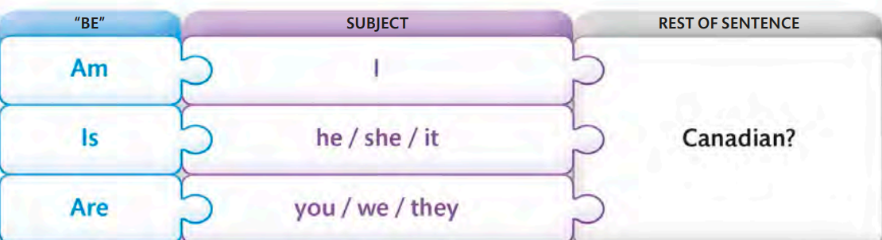

1. The past tense of ***be*** has two forms:

* Positive form

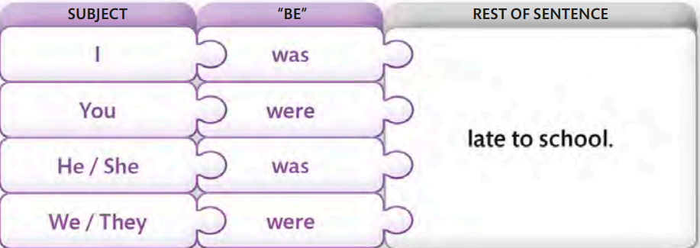

* Negative form

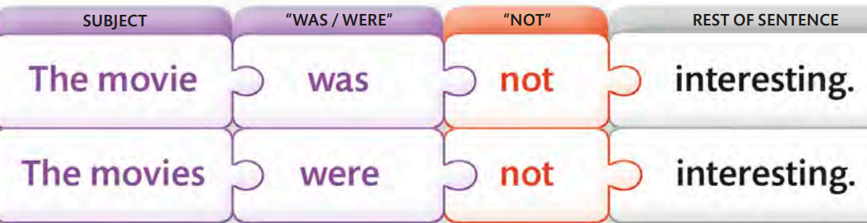

* Question

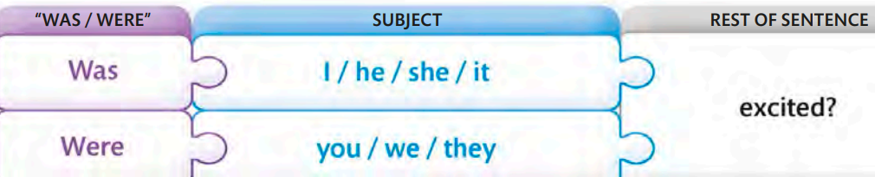

**Complete the conversation with the correct form of *be*. Then check your answers with a partner’s. Read the conversation together.**



**Friendship Force International**

**Changing the Way You See the World**



Q: What kind of people does the Friendship Force look for?

A: Friendship Force visitors 1. _______ interested in other cultures. They 2. (not)________ afraid of new places.

Q: 3. _______ it necessary to speak another language?

A: No, it 4. (not)________! Language 5. (not)_________ a big problem for the visitors.

Q: What if we have a problem when we 6. __________ in another country?

A: Every Friendship Force group has a leader. The leader 7._______ always near you. For example, last year, one visitor 8. ________ sick in Germany. Her host family called her Friendship Force leader. The leader took her to the doctor immediately. Luckily, she 9. (not)________ very sick. The next day, she 10.______ fine. So remember, when you travel with the Friendship Force, you 11. (not)_______ alone.

Q: I really want to travel with the Friendship Force, but I 12. (not)_______ sure when I can go. 13. _______ that a problem?

A: No, that 14. (not)_____ a problem. There 15. _______ many different groups very year. The schedule 16. ________ on our website.

**VII. SPEAKING SKILL**

**ASKING FOR MORE INFORMATION**

Sometimes in a conversation, we wantto know more information

Here are some useful ways to ask someone for more information:

**Nina**: I’m interested in the Friendship Force, but **I have some questions**.

**Interviewer**: **Can you tell us about** your group? **I’d like to know more about** your host family.

**Annie**: And I also learned that language is not always so important.

**Interviewer**: **What do you mean**?

**Here are some useful phrases for asking for more information:**

|  |  |
| --- | --- |
| - I have a question / some questions.  - Can you tell (me / us) more about (it / that)?  - What do you mean? | - I’d like to know more about (that).  - Can I ask you a question?  - Why do you think so? |

Workwith a partner. Student A, read a statement. Student B, ask for more information. Student A, give Student B more information. Use the information from this unit or your own ideas.

**Example**

A: It’s important for high school students to live in a foreign country.

B: Why do you think so?

A: It’s the best way to learn about another country and to learn the language.

1. You can learn a lot when you travel.

2. With a friend, speaking the same language isn’t really important.

3. The Experiment in International Living program is really great!

4. Friendship Force groups are very special.

**Switch roles.**

5. Livingwith a host family is a great experience.

6. It’s very important to speak two languages.

7. Some people are really nervous when they go to a foreign country.

8. A world of friends is a world of peace.

**VIII. FINAL SPEAKING TASK**

In this activity, you are going to introduce one classmate to two other classmates. Try to use vocabulary, grammar, pronunciation, and language for asking for information form this unit.

**Step 1**: Work with a partner. Student A, ask Student B questions about his or her profession or major / favorite subject in school, hobbies, native country or city, and native language. Take notes on your partner’s answers. Then switch roles.

**Step 2**: Find another pair of students (Students C and D).

Student A, tell the pair four things about Student B.

Students C and D, after each piece of information, ask Student B for more information. Student B, answer the questions.

**Step 3**: Complete the activity three more times, switching roles each time so that everyone in the group has a chance to tell about someone, ask for more information, and give more information.

**Example**

A: I’m going to tell you about my friend Francisco, He’s new here.

C: **What do you mean**?

B: I moved here last week. I’m from Buenos Aires, Argentina.

A: Francisco speaks three languages.

D: That’s so cool! **What languages do you speak**?

B: I speak Spanish, Portuguese, and some English.

C: Wow. **Can I ask you a question?**

B: Sure.

D: How did you learn Portuguese?

B: Well, I lived in Brazil for a year in high school. It’s an amazing country.

D: **Why do you think so?**

B: Because I love soccer!

**IX. UNIT PROJECT**

The Friendship Force works for world peace. Learn about another organization that works for world peace.

**Step 1**: Choose an organization. You may choose from the following list.

* United States Peace Corps
* Medecins sans Frontieres (Doctors without Borders)
* Seeds of Peace
* World Peace Project for Children
* Artists without Borders
* Kids without Borders
* Peace through the Arts Camp

**Step 2**: Give information about the organization. Use the Internet or a library.

**Step 3**: Give a report about the organization to a small group of your classmates.

**Questions to Guide Your Research**

1. What is the name of the organization?
2. Who can belong to the organization?
3. What does the organization do?
4. Where did the organization begin? When?
5. Would you like to work for this organization? Why or why not?

**X. ALTERNATIVE SPEAKING TOPICS**

Discuss one of the topic. Try to use the vocabulary, grammar, pronunciation, and language for asking for information from the unit.

1. Do groups like Friendship Force, EIL, and AFS really help bring peace to the world? Why or why not?
2. Will there ever be peace in the world? Why or why not?
3. Did you ever live in another country? Tell about your experience there.

**TOPIC: UNDERSTANDING FEARS AND PHOBIAS**



**I. FOCUS ON THE TOPIC**

1. Look at the photo. Why are some people scared of snakes?

2. Why are some people scared of certain things?

3. Does having a fear of something change a person’s life? How?

**II. EXPRESS OIPINIONS**

**Discuss the questions with a partner**.

1. What do you think about the Eiffel Tower story? Do you sometimes get scared in high buildings?
2. Do you have a phobia? Do you know someone with a phobia? Explain.
3. Do you think books and doctors can help people with phobias? What other things can help? Explain.

**III. VOCABULARY**

1. Match the words and phrases on the left with the definitions on the right. Write the letter of the correct definition on the line.

|  |  |  |
| --- | --- | --- |
| _______  _______  _______  _______  _______  _______  _______  _______  _______  _______ | 1. a serious issue  2. be angry with  3. confused  4. fear  5. hurt  6. in danger  7. not your fault  8. just kidding  9. shake  10. still | a. you didn’t make a problem happen  b. I’m joking; I’m not serious.  c. in a situation that may hurt or kill you.  d. move back and forth quickly  e. feel mad or upset because something is not OK  f. up to now  g. make a person feel pain  h. not understanding  i. feeling of being in danger  j. a big problem |

1. **Read the conversation and notice the phrases in bold. Match the phrases on the left to the definitions on the right. Write the letter of the correct definition on the line**.

Young man: I can’t ride this bike. I’m going to fall!

Friend: **Calm down**. You can do it.

Young man: I don’t know how. **What’s wrong with me**?

Friend: **Come on**, you can do it. You need to **believe in yourself**.

Young man: How can I do that? I’m going to fall!

Friend: Just **keep going**. Don’t **give up**.

|  |  |  |
| --- | --- | --- |
| ________ | 1. believe in yourself | a. why do I have this problem? |
| ________ | 2. calm down | b. don’t stop doing something |
| ________ | 3. come on | c. stop feeling scared |
| ________ | 4. keep going | d. have a good opinion of yourself |
| ________ | 5. what’s wrong with me? | e. stop trying |
| ________ | 6. give up | f. something we say to help others feel stronger |

1. A psychologist is speaking to a young person. This young person is worried about having a phobia. Read the conversation and fill in the blanks with the words from the box. You will not use all of the words.

|  |  |  |
| --- | --- | --- |
| Calm down  Come on  Confused  Fear  hurt | In danger  Issue  Shake  Still  Wrong with |  |
|  |  |  |

**Psychologist:** So, why are you here today? How can I help?

**Young Man**: Well, I’m 25 years old, and some of my friends are getting married. I have a girlfriend, but when I think about getting married, I get a really strong feeling of 1.________. Do you think I have a phobia?

**Psychologist:** I don’t think so. Many people feel scared about getting married.

**Young Man**: Really? Are you sure I don’t have a phobia? How do you know?

**Psychologist:** First of all, people with phobias feel like they are 2. _______ when they are not. There’s really no reason to be scared. But you have a good reason. I think you’re scared because you’re not ready to get married.

**Young Man**: But my friends are ready. They’re getting married. What’s 3.________ me? Why am I so scared? Am I just a big baby?

**Psychologist:** 4. ________. Don’t be angry with yourself. This is a / an 5.________ for many people – not feeling ready to get married.

**Young Man**: Maybe you’re right. But when I think about getting married, my heart beats fast and my hands 6. ______. My whole body feels bad. Are you sure I don’t have a phobia?

**Psychologist:** I’m sure you don’t. There are good reasons to feel scared of getting married.

**Young Man**: What are they?

**Psychologist:** Well, first of all, marriage is not easy. Married people sometimes fight and 7. ______ each other. Sometimes they’re very unhappy. This is a big decision. Don’t get married if you’re not sure about it. Don’t do it if you feel 8. _______

**Young Man**: But what if I never get married? What about my parents? They really want me to get married, but I’m 9.________ not sure. My parents will be so angry!

**Psychologist:** Please, 10._______. Don’t get so upset. When you are ready to get married, you’ll know it. You’ll be happy, not scared.

**IV. EXPAND**

**1. Read the advertisement for an e-book, Power of Speaking in Public. Notice the words in bold.**

Do you know the 1st fear of Americans? Speaking in public! Are you afraid of speaking in public? You are not alone. This is very **common** problem. You can **deal with** your fear today. You can become more **confident**. Our e-book, Power of Speaking in Public, will really give you **power**. You will speak better and better. You will close all your fear of speaking in front of others. Try Power of Speaking in Public!

**2. Complete the sentences by matching each sentence beginning on the left with the correct ending on the right. Write the letter of the correct ending on the line**.

|  |  |  |
| --- | --- | --- |
| ________  ________  ________  ________ | 1. If a problem is common…  2. When you deal with a problem…  3. Confident people…  4. If you have power… | a. you find a way to solve it.  b. believe they can do things.  c. you can change a situation  d. many people have it. |
|  |  |  |

**V. CREATE**

**Look at the list of fears. Discuss the questions with a partner.**

* Elevators insects public speaking
* Dogs darkness driving

1. What kind of issues do people with these fears have?
2. What’s the best way to deal with these fears?
3. Which one of these fears do you think is common? Why?

**VI. GRAMMAR**

1. Read the excerpts. Then answer the questions

Anna: I always walked up stairs –and it took forever!

Psychologist: There! You did it! You crossed the bridge!

Allen: We crossed the bridge.

1. What are the verbs? Underline them.
2. How are the verbs similar? How are they different?

**SIMPE PAST**

Use the Simple past to describe finished actions or situations

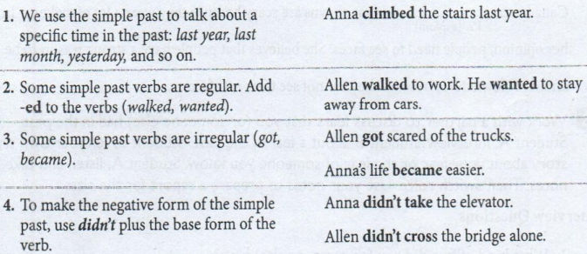

2. Read the information about fear of clowns. Complete the sentences with the simple past tense of each verb. Then work with a partner. Take turns reading each sentence aloud.



**THE FEAR OF CLOWNS**

Many children and adults react with fear to clowns. A few years ago, British psychologists 1. (study)______ the reaction of more than 250 children. They 2. (ask)_______ the children about pictures of clowns in a children’s hospital. All the children 3. (show) ______ strong fear. They 4. (say)________ that the clown pictures 5. (be) ______ scary. Also, in the 1990s, many adults 6. (get)_____ scared when they 7. (watch)______ the movie ***It.*** In this movie, a clown 8. (make)_____ friends and then 9. (hurt) _____ them. After watching this movie, some people 10. (cry) ______, and their hearts 11. (beat)_____ fast. Recently, one doctor in Canada 12. (explain) ______ that clowns are scary because they wear a lot of makeup. In her opinion, people need to see faces. She believes that people have a strong reason to be afraid of clowns. It is because they cannot see their real faces.

3. Work with a partner to discuss fears that you (or someone else) had in the past. Student A, interview Student B about a fear in the past. Student B, tell your own true story about your fear or the fear of someone you know. Student A, listen and take notes. Then switch roles. Use your notes to prepare a report for the class.

**Interview Questions**

1. What kind of fear did you (or someone else) have?
2. How old were you (or someone else)?
3. Why did you (or someone else) have this fear?
4. How did you (or the other person) feel? Were you angry or confused?
5. How did this fear change your life?

**Example**

My partner is Justin. When Justin was 10 years old, he was very afraid of dogs. He had a reason for this fear. One time, a big dog hurt his older brother. After this, he started shaking when he saw dogs. His heart beat faster, and he cried. He stayed home often. Sometimes, when friends invited him to their houses, didn’t go. He didn’t want to see their dogs.

**VII. PRONUNCIATION**

**PRONOUNCING –ED ENDINGS**



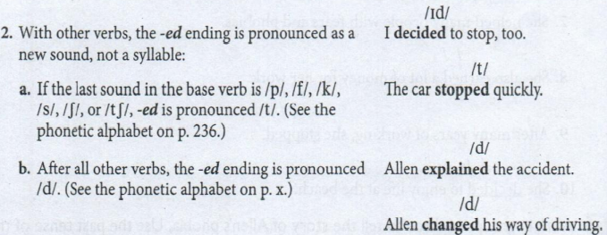

**3.** Work in groups of three to tell the story of Allen’s phobia. Use the past tense of the verb in parentheses to make a complete sentence. One person in the group will start the story and the other members of the group will continue the story. Be careful to pronounce the past tense ending correctly**.**

**Example**

When he was a young man, he

1. (start) to be afraid of many things.

The correct response is: When he was a young man, he ***started*** to be afraid of many things.

1. When he was a young man, he
2. (stop) driving his car.
3. (walk) to work every day.
4. (decide) to see a psychologist.
5. While working with the psychologist, he
6. (learn) a new way of thinking about himself.
7. (change) his old ideas about driving.
8. (try) to cross the bridge in his car.
9. After working with the psychologist, he
10. (want) to try new things.
11. (study) planes and flying.
12. (start) flying a small plane.

**VIII. SPEAKING SKILL**

**USE IMPERATIVES**

Speakers often use imperatives to give advice. An imperative is the command form of a verb. It is always in present tense. ***Don’t*** is used in the negative form. The subject is “you” since the speaker is giving a command to other people. However, the word you is not included in the imperative.

Work with a partner to give each other advice. Use imperatives. Student A, give advice for item 1-3. Student B, give for items 4-6.

1. B: I’m scared of taking my driving test.

A: Don’t ________. You can do it.

1. B: I don’t like elevators.

A: _________ instead!

1. B: I get scared when I travel alone.

A: ______. Then you won’t be alone!

1. A: I want a pet, but I’m afraid of dogs.

B: ________. They don’t bike.

1. A: I don’t want to fly to San Francisco from New York.

B: ________. You’ll see more.

1. A: I hate that clown movie!

B: Don’t ________. Play a game instead.

**IX. FINAL SPEAKING TASK**

In this task, you will create and perform a 1-3 minute role play about phobias. Try to use the vocabulary, grammar, pronunciation, and language for using imperatives that you learned in this unit.

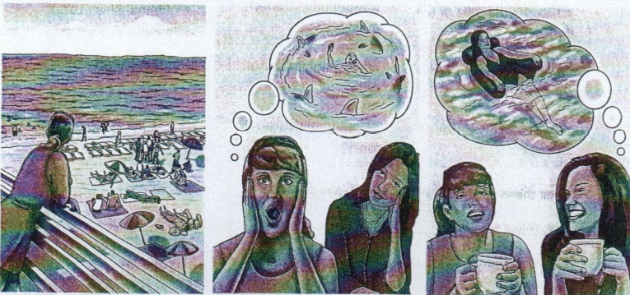

Work in pairs. Look at the story strip. Student A, you are a person with a water phobia. Student B, you have the same phobia, but your life is better today. Follow these steps:

Step 1: Think about the situation. Plan your conversation. Follow these points:

* Student A, explain your problem. Talk about your water phobia and all your problems –all the things you can’t do in your life.
* Student B, tell about your life in the past. You had a difficult life with your water phobia. But your life is better today. Give some advice to Student A.

Step 2: Practice the role play several times. Act like your character and speak naturally. As you practice, write notes about what you will say. Ask your teacher for help as needed.

Step 3: Perform your role play for the class.

**X. UNIT PROJECT**

Step 1: Look at the list of phobia. Use the Internet to learn more about one of them. Be sure to use a website that you can trust. The best websites to use are from the government, universities, or professional organizations.

|  |  |  |
| --- | --- | --- |
| Achluophobia (fear of the dark)  Botanophobia (fear of plants  Chrometophobia (fear of money) | Gamophobia (fear of marriage)  Ombrophobia (fear of rain)  Papyrophobia (fear of paper) | Scolionophobia (fear of school)  *Your own idea* |

**Answer these questions about one of the phobias**.

1. What is _________?
2. What kind of problems do people with __________ have?
3. What’s your advice for people with this phobia? What’s your advice for their family and friends?
4. What are some other interesting facts about ______?

Step 2: Prepare an oral report. Share your answers to the questions in Step 1.

Step 3: Give your report to the class. Try to answer questions about the phobia.

**XI. ALTERNATIVE SPEAKING TOPICS**

Discuss one of the topics. Use the vocabulary and grammar from the unit.

1. Do you believe that psychologist can really help people with their issues? Why or why not? What are some other ways to help people with their problems in life?
2. Tell the story of someone you know-a person with a serious issue in his or her life. (Serious include problems with health, money, fears, or other people). Is this person happy or unhappy? How does this person deal with his or her issues? What can we learn from this person?

**TOPIC: RISKS AND CHALLENGES**

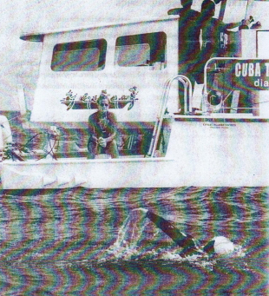

**I. FOCUS ON THE TOPIC**

1. What’s happening in this photo? Is it dangerous? What is the swimmer wearing?

2. Have you ever done something very difficult?

3. Have you ever done something that you were afraid to do?

**II. VOCABULARY**

1. Take turns with a partner. Look at the word in **bold** in the text. Then choose the best meaning. Your partner will tell you if he/she agrees or not. The first one has been done for you.

1. **A**: **Distance** is the amount of (*space*/*time*) between two places or things

**B**: ( Yes, I agree. / No, I don’t think so. I think it is the amount of…)

2. **A**: An **amazing** swimmer means "(*an excellent / a good*) swimmer."

**B**: (Yes, I agree. / No, I don't think so. I think it means...)

3. **A**: She **decided** means "She thought about something and (*made a choice / changed her mind*)."

**B**: (Yes, I agree. / No, I don't think so. I think it means she...)

4. **A**: She set **world records** means "She did things (*all over the world/ better than any other person in the world*)."

**B**: (Yes, I agree. / No, I don't think so. I think it means she...)

5. **A**: She tried to **reach her goal** means "She tried to do something that was (*he dream / very important*)."

**B**: (Yes, I agree. / No, I don't think so. I think it means she...)

6. **A**: **Unfortunately** means "This is (*lucky / sad*) information."

**B**: (Yes, I agree. / No, I don't think so. I think it means this...)

7. **A**: A **challenge** is something you enjoy doing because it is (*easy / difficult*).

**B**: (Yes, I agree. / No, I don't think so. I think it is...)

8. **A**: Jellyfish and sharks are **dangerous** because they (*can kill people/are in the ocean*).

**B**: (Yes, I agree./No, I don't think so. I think they are dangerous because they...)

9. **A**: She is **determined** means "No one (*can stop her/ is better than she is*)."

**B**: (Yes, I agree./No, I don't think so. I think it means no one...)

10. **A**: **Without** a shark cage means "(*outside a shark cage / with no shark cage*)."

**B**: (Yes, I agree. / No, I don't think so. I think it means...)

2. Work with a partner. Read the dialog and fill in the blanks with one of the words or phrases from the box. Then practice reading the conversation aloud.

|  |
| --- |
| careful - discover – prove (something) – strong – take a risk |

**A**: Why do people like to do dangerous sports like rock climbing and racecar driving?

**B**: I think those people enjoy doing dangerous things. They think it's very exciting to____________(1)

**A**: Yeah, but I think some people want to show the world that they can do something very dangerous and be successful.

**B**: Maybe you're right. A lot of risk-takers are trying to ________(2) to other people. They want to be the first person in the world to do something dangerous.

**A**: Yeah, like the guy who walked across Niagara Falls on a tightrope. He comes from a famous family of tightrope walkers. So they always try to__________(3) new ways to show people the dangerous things they can do.

**B**: Well, that's their job, right? But I think some people want to do dangerous things because they're really afraid, and they want to stop feeling that way. After they do something dangerous, they feel__________(4)

**A**: That's OK if they're successful. But what if they're not___________(5)

and they make a mistake? They can really get hurt, or even die! I think it's a little crazy.

**B**: I know. I’m not interested in doing dangerous things at all!

3. Read the homepage of the Adaptive Adventures website on the next page. Complete the text with the words and phrases in the box. Then take turns reading the text aloud with a partner.

Careful - challenges - dangerous - decided

Determined - discovered - proved - reach her goals

Strong - take a risk - unfortunately

***Adaptive Adventures -***

***Adventure programs for children and adults with disabilities***

Many people with physical disabilities think that they cannot do any sports. However, at Adaptive Adventures, we believe that everyone can do sports! We teach disabled people white water rafting, skiing, snowboarding, and many other exciting outdoor sports. Many disabled people don't do any sports because they think it's too ___________(1) for them, they are afraid that they will get hurt. However, for the past 12 years, we have _________(2) to our students again and again that this is not true. Our excellent instructors are very __________(3) when they teach disabled people, so our students are always safe. In fact, many of our instructors have disabilities, too, so they really understand how their students feel. They also know that many people with disabilities need new __________(4) in their lives. When people with disabilities __________(5) by trying something new, and they are successful, it is an exciting experience for them! Many students tell us that after they learned how to do a new sport, they _________(6) that they felt much more self-confident-not only about doing sports, but about all parts of their life. Here is what the father of one of our students said about us:

My wife and I both love to ski, so when our daughter was born with a disability, we thought that, ___________(7) she could never enjoy the sport that we love so much. When she was six, we heard about Adaptive Adventures, and we __________(8) to take her to your ski school for one week. This was the best decision we ever made! We learned that when your child has a disability, you have to keep teaching her to do new, more difficult things. This teaches her how to __________(9). Being successful helps her to become a__________(10) and happy person.

Now our daughter says that skiing is easy, and she is ___________(11) learn how to snowboard! Thank you Adaptive Adventures!

**III. EXPRESS OPINIONS**

Work in small groups. Discuss each question: Be prepared to share your ideas with the class

1. Why is Diana Nyad so determined to swim from Cuba to Florida? Is it always good to be so determined to reach a goal? Explain your opinion.
2. Why does Diana swim in the ocean without a shark cage?
3. Is Diana a good example for older people?

**IV. EXPAND**

Adjectives that end in **-ed** usually describe people's feelings. Adjectives that end in **-ing** usually describe people, things, or situations.

I was **amazed** when I heard about Diana Nyad. She is an **amazing** swimmer.

Here are some common **-ed** and **-ing** adjectives:

|  |
| --- |
| amazed - amazing - bored - boring  challenging - determined - disappointed - disappointing  excited - exciting - frightened - frightening  interested - interesting - scared - surprised  surprising - tired - tiring - worried |

Complete the sentences using any of the adjectives from the list. More than one answer may be possible. Be sure to use the correct form. Compare your answers with a partner's.

1. Diana Nyad thinks that long-distance swimming is *boring/challenging/tiring*

2. In my opinion, long-distance swimming is very_____________

3. Jeremy thought that rock dimbing was_____________

4. After he climbed up the mountain, Jeremy felt_____________

5. If my son or daughter goes rock climbing I will feel________________

6. Doing new things for the first time can be____________

7. Doing the same thing again and again is_______________

8. People who never stop trying to reach their goal are very______________

9. People were very___________in hearing Diana Nyad's story

10. When Diana couldn't finish her swim the fourth time, she probably felt very____________

**V. CREATE**

Work in small groups. Ask and answer the questions. Use the vocabulary from Review and Expand

1. Did you ever **take a risk**? What kind of **risk** was it? (Risks are not always physical. They can be mental, financial, cultural, or involve relationships with other people). Were you successful? How did you feel?

2. Did you ever do anything **dangerous**? What was it? Were you **careful**? How did you feel?

3. Did you ever feel very **determined** to do something? What was it? Were you

successful? How did you feel?

4. Did you ever **discover** something about yourself? What was it? How did you

**discover** it?

**VI. GRAMMAR**

1. Read the excerpts from the radio news report. Follow the directions

**a**. We're speaking to you from a boat.

**b**. She is still swimming even though things are not going very well right now.

**c**. Diana's wearing a special wetsuit.

**d**. I'm doing a lot of really hard things.

e. You're discovering some new things about yourself.

1. Underline the verbs in sentences a-e.

2. What are the two parts of the verb?_________+____________

3. What form of be is used after each subject?

I

You

They

He/She/It

Diana

We

Things

4. Which sentences from question I tell about an action right now/at this moment? Which sentences tell about a change that is happening these days (but not at this moment)?

**PRESENT CONTINUOUS**

**1**. Use the present continuous tense to describe actions or situations that are happening:

a. right now, at this moment,

or

b. now, as in this week, this month, this semester, this year, or these days.

Eg: She **is** still **swimming** even though things **are not going** very well.

Eg: You'**re** **discovering** some new things about yourself. I'm doing a lot of really hard things.

**2**. To form the present continuous, use the **present**

**tense of the *be* verb + the *-ing* form of the main verb**.

a. If the **main verb ends in *-e***, like ***have***, drop the ***-e*** and add ***-ing***

b. The verb ***swim*** has a consonant/vowell consonant pattern at the end. Double the final consonant before ***-ing***. Similar verbs include *get, begin, put, run*, and

*stop*.

Eg: I'**m doing** a lot of really hard things.

**Is** she **having** problems breathing?

Diana Nyad **is swimming** from Cuba to Florida.

3. For negative sentences, use the **be verb + not** (or **n't**) + **the main verb**.

Eg: She **is not giving** up.

Things **aren’t going** very well.

4. For ***yes/no*** questions, put the ***be* verb before the subject**

You can answer yes/no questions with a short answer: **subject + be verb**.

5. For ***wh-*** questions, **use the question word + be verb + subject + main verb**.

Eg: **Where is** she **swimming**?

**What are** you **doing**?

6. **Stative (non-action) verbs** are **not** used in present continuous, even though the action is happening right now.

a. Some common verbs that are **always** stative (non-action) are: *be, believe, hate, know, like, love, mean, need, understand*, and *want*.

Eg: Diana **knows** how to clear her mind.

She **likes** challenges!

b. Some verbs have two meanings a non-action meaning and an action meaning. Some common verbs with both meanings are: *feel have, look, see, smell, taste*, and *think*.

Eg: Everyone **thinks** I'm the “baby.”

Diana is counting. She **isn't thinking** about anything.

c. When the verb **have** is used in some expressions, it has an **action meaning**, and it can be used in present continuous. Some common expressions are: *have trouble, have difficulty, have problems, have fun, have a good time* and *have a party*

eg: She **is having difficulty** breathing.

We'**re having** a good time.

2. Work with a partner. Fill in the blanks with the correct form of the verb in parentheses. Use present continuous for action verbs, and simple present for non-action verbs. Then read the dialog aloud.

**A**: Hi. What_________ (you / do)?

**B**: I____________(watch) Diana Nyad, the famous swimmer.

**A**. _____________(she/swim)from Cuba to Florida again?

**B**. Yes! This is her fifth time, and this time she's finally going to make it. She_______________(swim) the last few feet right now. This_________(be) so exciting!

**A**: Look, she_________(stand) up and___________(get)out of the water. She did it!

**B**: I___________(know). I can't believe it. And look at all the people on the beach. They__________(cheer) and ___________(scream)

**A**: But look at Diana's face. Wow, she­__________(look) terrible. She's really sunburned and she__________(have trouble) standing up. Her friend___________(help) her to walk.

**B**: Well, that's because she's so tired. She just swam for 53 hours!

**A**: But she___________(smile) now. It looks like she__________(want) say something. A reporter___________(go) over to talk to her.

**Reporter 1**: Sixty-four-year-old Diana Nyad has just finished her historic swim from Havana, Cuba, to Key West, Florida. She is the first person in the world to do this without a shark cage, and she is also the first person in the world to swim for 53 hours!

**Reporter 2**: Diana, congratulations! Millions of people all over the world________(watch) you on TV right now and they_________(be) all so excited that you reached your goal!

Do____________(you/have) something to say to all the people who___________(love) you and___________(watch) you right now?

**Diana**: I've got three messages. One is "we should never ever give up." Two is "you_________(be) never too old to chase your dreams." And three is __________(look) like a solitary sport, but it's a team [effort]."

**VII. SPEAKING SKILL**

EXPRESS UNEXPECTED RESULTS WITH ***EVEN THOUGH***

To show that a result is unusual or not expected, we often use the words ***even though*** before the cause.

**Example**

**Even though** things are not going very well, Diana is still swimming.

[cause] [result]

Or

Diana is still swimming **even though** things are not going very well.

[result] [cause]

**Remember**: Do not use the word ***but*** when you use even though.

1. Take turns with a partner. Choose the correct result for each cause. Remember, when you use ***even though***, the result must be surprising or unexpected. Read the sentences aloud.
2. Even though I’m a very good swimmer,________.
3. I’m afraid to swim in the ocean
4. I like to swim in the ocean
5. Even though I tried very hard, ________
6. I reached my goal
7. I didn’t reach my goal
8. _______ even though it’s dangerous.
9. I like to go rock climbing
10. I don’t like to go rock climbing
11. _______ even though I was frightened.
12. I’m happy that I went whitewater rafting
13. I’m happy that I didn’t go whitewater rafting

2. Work with a partner. Read these sentences about Diana Nyad. Then connect the sentences using **even though**. Decide which sentence tells the cause and which sentence tells the result. Remember to put **even though** before the cause. Read the sentences aloud.

**Example**

Diana was very tired. She continued so swim.

[cause] [result]

**Even though** Diana was very tired, she continued so swim.

Or

Diana continued so swim **even though** she was very tired.

1. Diana is an amazing swimmer. She is 64 years old.
2. Diana tried four times and was not successful. She wanted to try again.
3. Diana swam for more than 50 hours. It was very difficult.
4. There were dangerous sharks in the ocean. Diana swam without a shark cage.
5. The jellyfish bit Diana. She wore a special wetsuit.
6. The swim from Cuba was ling and difficult. Diana was so happy that she did it.

3. Complete each sentence with a cause or an unexpected result that makes sense. Then, compare your sentences with a partner.

1. Even though I’m afraid of high places, I ________

2. I want to join Outward Bound even though _______

3. Some people enjoy taking risks even though _______

4. I decided to ______ even though ________

5. Even though ____________, I’m very determined to do it.

6. Some people are afraid to fly in airplanes even though ________

**VIII. FINAL SPEAKING TASK**

A role play is a short performance. The students take on roles, or become characters, and act out a situation.

In this activity, you are going to role-play an interview with a risk-taker.

Use the vocabulary, grammar, pronunciation, and language for expressing unexpected results from this unit.

You are going to role-play an interview between a TV news reporter and a risk-taker.

**Step 1**: Together with the class, think of at least six interesting questions to ask the risk-taker. Write them down.

**Step 2**: Work with a partner. Student A, you are a TV news reporter. You are interviewing a risk-taker while he / she is doing something very challenging or dangerous. Use the questions that you wrote down in Step 1 and any others you want to ask.

Student B, you are a risk-taker. You can be an athlete, an entertainer, or any other person who is doing something very challenging or dangerous. You can also be yourself if you can tell about a time that you took a risk. (Remember that a risk or challenge is not always physical). Answer the questions that the TV news reporter asks you.

**Step 3**: When you are finished, change roles. Student A, choose a different risk-taker to role-play. Student B. you are the TV news reporter.

**IX. ALTERNATIVE SPEAKING TOPICS**

Discuss one of the topics. Use the grammar, vocabulary, pronunciation, and language for expressing unexpected results from this unit.

1. "Please know that I am aware of the hazards. I want to do it because I want to do it. Women must try to do things as men have tried. When they fail, their failure must be a challenge to others." --- Amelia Earhart, American (1897-1937)

Explain this quote by Amelia Earhart. What does she mean? Do you agree with her? Why or why not?

2. Did you ever do any dangerous sports? Did you ever live in nature, without a cell phone, computer, TV, etc.? Tell about your experiences. If you never did these things, do you want to? Why or why not?

3. There are many famous sayings and quotes about determination and challenges. Look at the list below. Explain what each saying or quote means and give an example. Then tell if you agree or disagree with it, and explain why.

a. If at first you don't succeed, try, try again.

b. Where there's a will, there's a way.

c. I've failed over and over and over again in my life and that is why I succeed. - Michael Jordan

d. I hated every minute of training, but I said, "Don't quit. Suffer' now and live the rest of your life as a champion. --Muhammad Ali

e. Take risks: if you win, you will be happy; if you lose, you will be wise.

**TOPIC: ONLY CHILD – LONELY CHILD**



**I. FOCUS ON THE TOPIC:**

1. Read the title of the unit. What is an only child? What does the title mean?

2. In your country, how many children do most families have?

3. How many students in the class are only children? How many students have one brother or sister? Two? Three or more?

**II. VOCABULARY: CHANGING FAMILIES**

1. Lisa and Jules Conner are the parents of an only child. They started a new blog for one-child families. Work with a partner. Read the conversation that they posted on their blog. Choose the correct word for each blank.

A Conversation with the Bloggers: *Lisa and Jules Conner*

**Lisa**: Welcome to “Our Only Child!" "Our Only Child" is the first blog for families like us-happy families with just one child. We started this blog because we want to share information with other one-child families.

**Jules**: Many people think that only children are 1. (intelligent / lonely)____________. However, we all know because they don't have

2. (a baby / siblings)_______________ that this is not true!

**Lisa**: Of course it's not true! We can spend a lot of time with our children

because we don't have to 3. (afford / take care of)___________other children. Many parents with large families don't have enough time to do this, especially if both parents work full-time. Parents with one child don't have this problem.

**Jules**: We also know that friends are very important to only children. Many of us move to neighborhoods with lots of young families, so our children can make a lot of friends.

**Lisa**: We also want to share information from the latest studies about one child families. Here's some very interesting information: Only 3 percent of the American 4. (population / personal)__________say that a one-child family is the best family size. But recently, Time Magazine said that one-third (33 percent) of young Americans plan to 5. (have / make)___________ just one 6. (child /money)____________ after they 7. (get married / take care of)

**Jules**: Why is this? Of course, every family is different, so this is a very 8. (personal / population)__________ decision for every couple. But life in most American cities today is expensive. It costs between $286,000 and $324,000 to 9. (raise / have)___________ a child to age 18 in the U.S. -and that's before paying for college! Many parents today don't 10. (have / make)___________ enough 11. (children / money)______________at their jobs, so they 12. (can't afford / make money)______________ to have a big family.

**Lisa**: That's one reason that many Americans today are 13. (having / making)___________ the 14. (time / responsible)_____________ decision to have just one child and to give their child the best life possible!

Lisa Conner Jules Conner

Bloggers, *Our Only Child*

1. Match the vocabulary on the left with the correct definition on the right. Write the letter of the correct definition on the line.

|  |  |
| --- | --- |
| ___1. can't afford  ___2. get married  ___3. have a child  ___4. lonely  ___5. make a decision  ___6. make money  ___7. personal  ___8. population  ___9. raise  ___10. responsible  ___11. sibling  ___12. take care of | a. brother or sister  b. decide; choose  c. do everything that someone needs; watch over  d. have a husband or wife; marry (someone)  e. right or correct for a certain situation  f. bring up a child; give a child a home, food, clothing, and education until the age of 18  g. don't have enough money (to do something)  h. give birth to a baby  i. individual; different for every person  j. sad because you are alone k. earn money from your job. 1. the number of people in a city, country, the world |

1. Take turns with a partner. Student A, read your sentence. Student B, use one of the words in the box to help you to respond to Student A in a complete sentence. You will also need to add your own words.

|  |
| --- |
| act - alone - have fun - mature - opportunities |

1. **A**: Why did Jay's family decide to move to Chicago?

**B**: They wanted Jay to take classes in music and art, but their small town didn't ___________

2. **A**: Lisa is only 11, but she reads the newspaper every day, and she can discuss the news like an adult.

**B**: I know. She__________. Most 11-year-old kids aren't interested in the news at all.

3. **A**: I'm worried about Ryan. His teacher said he was mean to one of his classmates today.

**B**: Really? How did__________?

4. **A**: There is an international party at my school tonight. Do you want to come?

**B**: Yes, thanks! That sounds great. I'm sure_____________

5. **A**: I'm really sorry that I can't go to the soccer match with you tomorrow.

**B**: Please don't worry about it. I can______________. It's not a problem for me.

1. Work in pairs. Student A, read your sentence aloud. Student B, read your sentence aloud and fill in the blank with the correct word from the box.

tired - decision - had fun - lonely

personal - raise - took care of

**A**: Did both of your parents work when you were a child?

**B**: Yes, but my grandmother lived with us. She helped my parents to *raise* me

**A**: Really? That's unusual in the U.S.

**B**: I know, but my parents are both doctors. They worked a lot, and when they came home, they were really________

**A**: Sure ...

**B**: So my grandmother_________me during the week.

**A**: Did you like that?

**B**: Yes, I loved it. She always had a lot of time to play with me, and we always___________ together. I was never__________

**A**: That's great.

**B**: Yeah, and we also talked a lot about so many things. My grandmother always helped me if I had a_____________ problem, and she taught me how to make the best_____________

**A**: You were lucky!

**B**: Yeah, I agree.

**Now switch roles**.

can't afford - got married - have

make a lot of money - opportunities - take care of

B: Did I tell you the news about my brother and sister-in-law?

A: No. What's happening with them?

B: Well, you know that they__________ a year ago, right?

A: Yeah...

B: Well, now they're going to______________ a baby!

A: That's great!

B: I know. I can't believe it!

A: It's very exciting. Is Joan going to stop working after she has the baby?

B: I think she's going to stay home for three months and then she's going to go back to work. They_____________ to live on just one salary.

A: Really? Doesn't your brother have a good job?

B: Well, he loves his job, and he has a lot of___________ to travel, but

unfortunately, he doesn't __________

A: Oh, so I guess they're going to get a babysitter.

B: Yeah, and my mother is going to help them to___________ the baby, too.

A: That's nice.

**III. EXPRESS OIPINIONS**

1. **Read the statements. Mark each one A (Agree) or D (Disagree). Then discuss your opinions with the class.**

_____ 1. It’s better for children to have young parents.

_____ 2. Only children are more popular than children with siblings.

_____ 3. People need to think about the population problem in the world when they decide how many children to have.

1. What are the advantages of having only one child? What are the advantages of being an only child? Write the advantages in the chart or on a sheet of paper. Use the cues in each box to make a complete sentence. Then compare your chart with a partner's. Number 1 has been done for you.

|  |  |
| --- | --- |
| **ADVANTAGES FOR PARENTS** | **ADVANTAGES FOR ONLY CHILDREN** |
| 1.In big cities, / less expensive / raise / one  *In big cities, it's less expensive to raise just one child* | 1. In big cities, only children/have/  opportunities  *In big cities, only children may have more opportunities* |
| 2. Parents / afford / give / only children/a good | 2. Some only children / special |
| 3. For older parents,/it/ easier / raise / just one | 3. Only children/learn/ enjoy / spend / alone |
| 4. Parents / spend / more time /an/ child | 4. Only children / more popular and  intelligent/children / siblings |
| 5. It / more responsible /have/child because of/ population | 5. Only children / more mature / children with siblings |

**3.** Student A thinks it's good to have **more than one child**. Student B thinks it's better to have **only one child**. Role-play. Work with a partner. Complete the conversation orally with information from Step 1: Organize. Add five more lines for Student A and for Student B. Begin like this:

**A**: Do you really believe that it's best to have just one child?

**B**: Of course, especially in big cities. It's less expensive to raise just one child in a big city.

**A**: That's true. In big cities, parents can afford to give their children more ...

**B**: Also, parents with only one child can spend ...

**A**: Well, that's true. But some children really want a sibling.

**B**: Yes, but...

**A**: ...

**IV. EXPAND**

1. This is a page from the Conner’s blog, “Only Our Child”. Read Columns A and B

|  |  |
| --- | --- |
| **A** | **B** |
| Some people think that only children have a lot of problems.  ***They say:***  *"Problem" #1: Only children are* ***selfish****.*  Only children get all of their parents' attention, so they think they are the most important people in the world. They never think about other people. These children are **selfish**. This means ________.  *"Problem" #2: Only children are* ***spoiled****.*  Parents of only children are sad that their child has no siblings. They think that toys, money, and other things can make their child feel happy. But the child keeps asking for more and more. These children are **spoiled**. This means_________  *"Problem" #3: Only* ***children don't get along well with*** *other children.*  Only children live with adults, so they don't learn how to act like children. They act like "little adults." They don't learn how to play with other children, and they don't feel comfortable with them. Only children **don't get along well with** other children. This means________ | Parents of only children know this is not true!  ***We say:***  ________*We and our children are happy with our families. We don't need to buy our children lots of toys to make them happy. But our children spend more time playing by themselves, so they learn how to be alone. They are more* ***independent*** *than children with siblings. This means__________.*  *Our children are usually more mature than other children their age, but we know that it's very important for them to have friends. We make sure that our children always have friends to play with. Our children are usually very popular with other children. They* ***have many******close friends****. This means____________*  *________We give our children a lot of attention. This makes our children feel good about themselves. They also care about other people. Our children are usually* ***self-confident****, not selfish. This means___________* |

1. Match the vocabulary **in bold** with the correct definitions below. Write the letter of the correct definition in the blank at the end of each paragraph. Then, check your answers with a partner.

**Definitions:**

a. they have a lot of very good friends

b. they can do many things without help

c. they think only about themselves

d. they believe they are good people, with good abilities

e. they have problems with other children

f. they are never satisfied. They always want more and more things

3. Work with a partner. Match the problem in Column A with the best response by the "Our Only Child" bloggers in Column B. Write the number of the problem on the line in front of the best response.

4. Change partners. Take turns reading the problems and responses aloud with your new partner. Student A, read one problem. Then Student B, read the correct response. Check with your teacher if you have different responses to the problems.

**V. CREATE**

Work with a small group of students. Talk about each idea in the blog post. Which ideas do you think are true? Why? Use the vocabulary from Review and Expand.

**Example**

Only children are selfish. / Only children are self-confident.

**STUDENT A**: I think most only children are selfish. It's natural. Only children spend a lot of time alone. They don't learn how to think about other people's feelings. That's why they are selfish.

**STUDENT B**: I'm not sure about that. In my opinion,...

**STUDENT C**: 1... because ...

1. Only children are spoiled. / Only children are independent.

2. Only children don't act like children. / Only children are mature.

3. Only children don't get along well with other children. / Only children have many close friends.

**VI. GRAMMAR**

1. Read Maria's sentences. Look at the underlined verbs. Then answer the questions.

MARIA: Today we're going to talk about only children.

MARIA: Next, I'm going to talk to the kids.

1. How many parts does each verb have?

2. What is the first part?

3. What is the second part? Does it change?

4. What's the form of the last part?

|  |  |
| --- | --- |
| **THE FUTURE WITH *BE GOING TO*** | |
| 1. **Use *be* + *going* *to* + the base form of the verb** to talk about an action in the future.  **Note**: Use contractions in speaking and in informal writing. | I **am going to have** lunch later.  He **is going to visit** friends tonight. **I'm going to have** lunch later.  He'**s going to visit** friends tonight. |
| 2. To make a negative sentence, put ***not* before *going to***.  **NOTE**: You can also use the negative  contractions *isn't* and *aren't*. | I'm **not going to** travel next week. She's **not going to** have a big family. He is**n't going to** get married soon. We are**n't going to** have a big family. |
| 3. To make questions, put a form of ***be* before the subject**. | **Are you** going to visit us soon? **Where is he** going to go next year? |
| 4. To answer ***yes/no*** questions, you can use a short form:  *Yes* + subject + *be*  *No* + subject + *be* + *not*  **Note**: You can also use the negative  contractions *isn't* and *aren't*. | Yes, I am/he is / you are / we are they are.  No, I'm not / he's not / you're not/ we're not they're not.  No, he is**n't**./No, they are**n't**. |
| 5. You can use these future time expressions with ***be going to***:  later/ tonight/tomorrow / soon  in two days / in a week/in a month / in a year  this Tuesday / week / month/year  next Monday/week/month/year | I'**m going to** move to a different city **next year**.  We'**re going to** have dinner together **this week**. |

222. Tonia is talking about her plans for the future. Complete the conversation with the correct forms of ***be going to***. Then read the conversation aloud with a partner.

**MARIA**: I know you don't like being an only child. So, _______________

you ____________have a big family when you grow up?

**TONIA**: Yes, definitely! I _____________have four or five kids! Maybe six!

**MARIA**: Well, then your children________________be lonely!

**TONIA**: Right. They_____________have a lot of brothers and sisters to play

with.

**MARIA**: But, you know, raising so many kids is very expensive!

**TONIA**: Well, I_____________work hard and save a lot of money. I ____________be rich!

**MARIA**: You____________be rich? That's amazing!

3. Work with a small group of students.

1. On a small piece of paper, write a question using ***be going to*** and a phrase from columns A and B. Put all questions in a paper bag. Give your bag to another group.

2. Take turns. Choose a question from the bag. Read it aloud. The next student has to answer it using ***be going to***. Ask and answer all the questions in the bag.

|  |  |
| --- | --- |
| A  go shopping  take a vacation  move to a different city/country  move to the countryside  see a movie  study another language  buy a car  have a big family  get a new job | B  this year  next week  in a month  soon  tonight  tomorrow  in _____ years  this weekend  in the future |

**Examples**: Are you going to move to a different city this year?

Are you going to see a movie tonight?

**VII. SPEAKING SKILL**

**AGREEING AND DISAGREEING**

There are many ways to agree with another person's opinion, and to disagree politely. Here are some common phrases you can use:

|  |  |
| --- | --- |
| TO AGREE | TO DISAGREE |
| I agree (with you)  (I think) You’re right  (I think) That’s true  That’s for sure | I disagree  I don’t agree (with you)  I don’t think that’s true./ I don’t think so.  That’s not true |
| WHEN YOU’RE NOT SURE | |
| I’m not sure about that  That may be true, but…..  Maybe………… | |

**Examples**

MARION: But... well, it's not easy to raise a young child at our age.

MARK: **That's for sure**. We're always tired!

MARIA: I think many young parents feel the same way!

MARION: Mmm... **Maybe**.

Tom: I'm sure you know, teachers don't make a lot of money!

MARIA: **That's true**. Most teachers aren't rich!

Work in groups of four. Two students will be Group A and two students will be Group B. One student from Group A, read the statement in number that you think is true. Then one student from Group B, use a phrase to agree, disagree, or say you're not sure about Group A's statement. Explain why and state your opinion. Continue taking turns stating opinions and agreeing or disagreeing.

**Example**

A: Most only children feel very different from their friends.

B: I don't agree. In most big cities, there are lots of only children!

**Statements**

1. Most only children (*feel / don't feel*) very different from their friends.

2. Only children (*are / are not*) more popular than children with siblings.

3. Only children (*are / are not*) more mature than children with siblings.

4. Many only children (*are / are not*) spoiled.

5. It's (*good / not good*) to be the youngest child in a family.

6. It's (*good / not good*) to be the oldest child in a family.

7. (*All /Not all*) children need siblings.

8. Many only children (*have trouble / don't have trouble*) making friends.

9. It's (*fine / not responsible*) to have more than one child.

10. Children (*need / don't need*) to learn how to enjoy being alone.

**VIII. FINAL SPEAKING TASK**

*In this activity, you will role-play a conversation between Matt and Jessica*. Matt and Jessica are married. They have a four-year-old daughter named Katie. They are talking about having a second child. Matt is 35 years old. He wants to have another child. Jessica is 34. She isn't sure if another child is a good idea. Try to use the vocabulary, grammar, pronunciation, and language for agreeing and disagreeing from this unit.

Read about Matt, Jessica and Katie:

|  |  |  |
| --- | --- | --- |
| **MATT** | **JESSICA** | **KATIE** |
| * Apartment: nice but very small * Rent: expensive | | |
| * job: engineer for a large company * siblings: two brothers, and   they're all very close   * thinks it's important to have   a sibling   * wants another child | * job:   -day: teaches music in high school  -some weekday and weekend evenings: sings at a jazz club   * siblings: one brother, but they're not very close * doesn't think it's important to have a sibling * not sure if they should have another child | * spends time with her grandmother or babysitter when Matt and Jessica are working * plays with a lot of friends in the neighborhood * likes to:   -read children's books in her  room  -play with her toys  -watch children's videos  -play games on the computer |

**Follow the steps.**

STEP 1: The teacher will divide the class into two groups.

STEP 2: Group A: You are Matt. Make a list of reasons that you want to have another child.

1. *It's important for children to have siblings*.
2. __________________________________
3. __________________________________
4. __________________________________
5. __________________________________
6. __________________________________

Group B: You are Jessica. Make a list of reasons that you don’t want to have another child

1. *Siblings aren’t always close.*
2. __________________________________
3. __________________________________
4. __________________________________
5. __________________________________
6. __________________________________

STEP 3: Work with a partner from the other group. Role-play a conversation between Matt and Jessica. Talk about the future. Use the reasons on your lists. Try to make a decision about having another child.

STEP 4: Share your decisions with the class. How many pairs decided to have another child? How many decided not to have one? Explain your reasons.

**XIX. ALTERNATIVE SPEAKING TOPICS**

Discuss one of the topics. Use the vocabulary and grammar from this unit.

1. Look at the graph. What does it show about the number of American families with only one child? Is the same thing happening where you live? Do you know why?

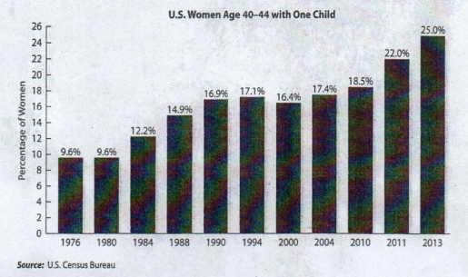

2. Do you think it's good to have only one child? Why or why not?

3. How many children do you want to have? (OR: How many children do you have?)

a. Does your decision have anything to do with the cost of raising a child?

(In the U.S., the cost of raising one child for the first 17 years of life is

$286,000 - $324,000, before paying for college.)

b. Does your decision have anything to do with the population explosion in the

world?

c. Do you have other reasons? What are they?