**Poem: The Road Not Taken (1916)**

**Author: Robert Frost**

**Literary Lesson: Theme**

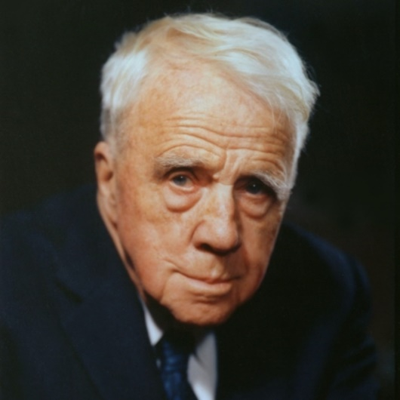**Robert Lee Frost** (March 26, 1874 – January 29, 1963) was an American poet, whose personal life was plagued by grief and loss. Although known for his later association with rural life, Frost grew up in the city, and he published his first poem *My Butterfly. An Elegy* in his high school's magazine. Frost worked the farm for nine years while writing early in the mornings and producing many of the poems that would later become famous. His first book of poetry, *A Boy's Will*, was published in 1913. Frost met or befriended many contemporary poets in England, especially after his first two poetry volumes were published in London in 1913 (*A Boy's Will*) and 1914 (*North of Boston*). In 1915, he bought a farm in Franconia, New Hampshire, where he launched a career of writing, teaching, and lecturing. In 1924, he won the first of four Pulitzer Prizes for the book *New Hampshire: A Poem with Notes and Grace Notes*. He would win additional Pulitzers for *Collected Poems* in 1931,*A Further Range* in 1937,and *A Witness Tree* in 1943.

Known for his realistic depictions of rural life and his command of American colloquial speech,Frost frequently wrote about settings from rural life in New England in the early twentieth century, using them to examine complex social and philosophical themes. Because Robert was a farmer first, a poet second (he owned five farms, all in Vermont), his poems are more than rooted in the state’s landscape: its stony and frugal soil, its sculptured and shimmering green lens bespeaking a timeless and mystical perfection and its early winter melancholies.

Frost's poems show a successful striving for utter colloquialism, a combination of his use of traditional forms and modernism with his use of idiomatic language and ordinary, everyday subject matter. He won almost immediate recognition for the simple beauty of his verse; his sensitive, observing spirit; his quick sympathies and gentle understanding-all revealed in simple language that has the tang and twist of Yankee speech. His poems show universal thoughts, and feelings which underline the picture so vividly sketched. Frost’s language is deceptively simple. His poems say more than they seem to.

Frost was honored frequently during his lifetime, and became one of America's rare public literary figures, almost an artistic institution. He was awarded the Congressional Gold Medal in 1960 for his poetic works. On July 22, 1961, Frost was named poet laureate of Vermont.

(Sources: <https://en.wikipedia.org/wiki/Robert_Frost>

https://www.nytimes.com/1991/09/01/travel/robert-frost-s-vermont.html)

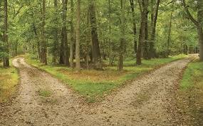

**A. Before reading**

**I. Think before you read**

1. What do you think the title of the poem means?
2. Imagine you are standing in front of the crossroads, one of which is unexplored and very new to you; meanwhile the other is very familiar and safe. Which road do you think you will choose to keep going? Can you explain your decision?

**The Road Not Taken**

Two roads diverged in a yellow wood,

And sorry I could not travel both

And be one traveler, long I stood

And looked down one as far as I could

To where it bent in the undergrowth;

Then took the other, as just as fair,

And having perhaps the better claim,

Because it was grassy and wanted wear;

Though as for that the passing there

Had worn them really about the same,

And both that morning equally lay

In leaves no step had trodden black.

Oh, I kept the first for another day!

Yet knowing how way leads on to way,

I doubted if I should ever come back.

I shall be telling this with a sigh

Somewhere ages and ages hence:

Two roads diverged in a wood, and I—

I took the one less traveled by,

And that has made all the difference.

**B. After reading**

**I. Vocabulary**

***Direction****: Match the vocabulary from the poem in column A (1-6) and its definition in column B (A-F)  
 Column A Column B*1. claim A. from this time   
2. diverged B. walked on   
3. fair C. small trees and plants growing beneath larger   
4. hence D. branched off; moved in a different direction  
5. undergrowth E. interest, appeal   
6. trodden F. beautiful, favorable

**II. Theme and Conflicts**

1. What conflict was the traveler facing at the beginning of the poem?
2. Which road did the traveler take, the first or the second? What makes his choice?
3. How is the road taken described?
4. How can you explain for the “sigh” the traveler had in the line *“I shall be* *telling this with a sigh”*
5. What do the last two lines of the poem mean? From what you know about the poet’s life, what “difference” did the poet refer to in the last line?
6. Why did the poet name this poem *The Road Not Taken*, not *The Road Taken*?