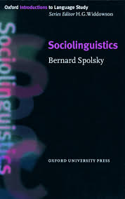

Sociolinguistics is the study of the different ways in which different groups of people use language. This book provides a brief but comprehensive introduction to the field, making links with related disciplines such as history, politics, and gender studies. (**Bernard Spolsky _ 1998**)

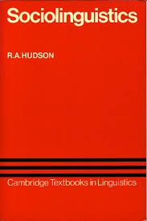

This new edition of Richard Hudson's widely acclaimed textbook Sociolinguistics will be welcomed by students and teachers alike. To reflect changes in the field since publication of the first edition in 1980, the author has added new sections on politeness, accommodation, and prototypes; and he has expanded discussion of sex differences, culture and general theory. There remains coverage of classic topics such as varieties of language, speech as social interaction, the quantitative study of speech, and linguistic and social inequality. Like the first, the second edition of Sociolinguistics is an exceptionally clear and helpful overview of the relationship of language and society. (**Richard A Hudson,** 1996)

# D:\Các văn bản hành chính\Văn bản ĐT-GD-CVHT-SV\E Teachin & Learning 4.2020\COURSES IMAGES (COVERS)\Course image (Socioling.).jpg

# A fully revised new edition of Ronald Wardhaugh's popular introduction to sociolinguistics, which now includes over 150 new and updated references and new study features throughout Features new "Explorations" sections in each chapter incorporating suggested readings, discussion sections, and exercises - all designed to encourage students to develop their own skills and ideas Reflects new developments in the field, providing greater focus on ideas such as identity, solidarity, and markedness Provides balanced coverage of a range of topics, including: language dialects, pidgins and Creoles, codes, bilingualism, speech communities, variation, words and culture, ethnographies, solidarity and politeness, talk and action, gender, disadvantage, and planning Comprehensive and accessible, it is the ideal introduction for students coming to sociolinguistics for the first time Ronald Wardhaugh _ 7th edition (2006)

<https://studylib.net/doc/7869271/syntax-and-sociolinguistics>

<https://www.hf.uio.no/multiling/english/publications/2020/>

<https://www.degruyter.com/search?source=%2Fjournals%2Fijsl%2Fijsl-overview.xml>