|  |  |  |  |  |  |  |  |  |
| --- | --- | --- | --- | --- | --- | --- | --- | --- |
|  | **THE PRE-COURSE TEST** | | | | | | | |
|  | **2021 - 2022** | | |  | | **II** | |
|  | **Chính quy** | | | | | | |
| **Môn thi:** | **NGHE 2** | | | | | | |
|  | |  | |  |  | | |
|  | | | **40 phút** |  | | | **2** |
|  |  | | |  |  | | |  |
|  | | | | | | | | |

**ĐỀ THI**

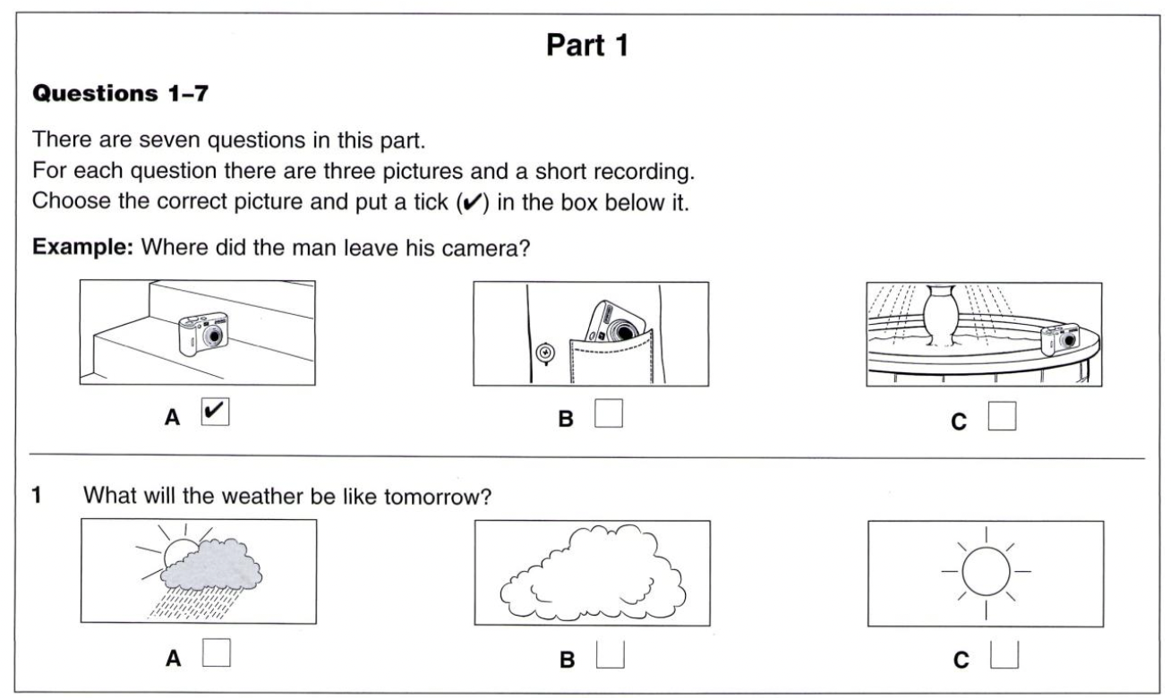

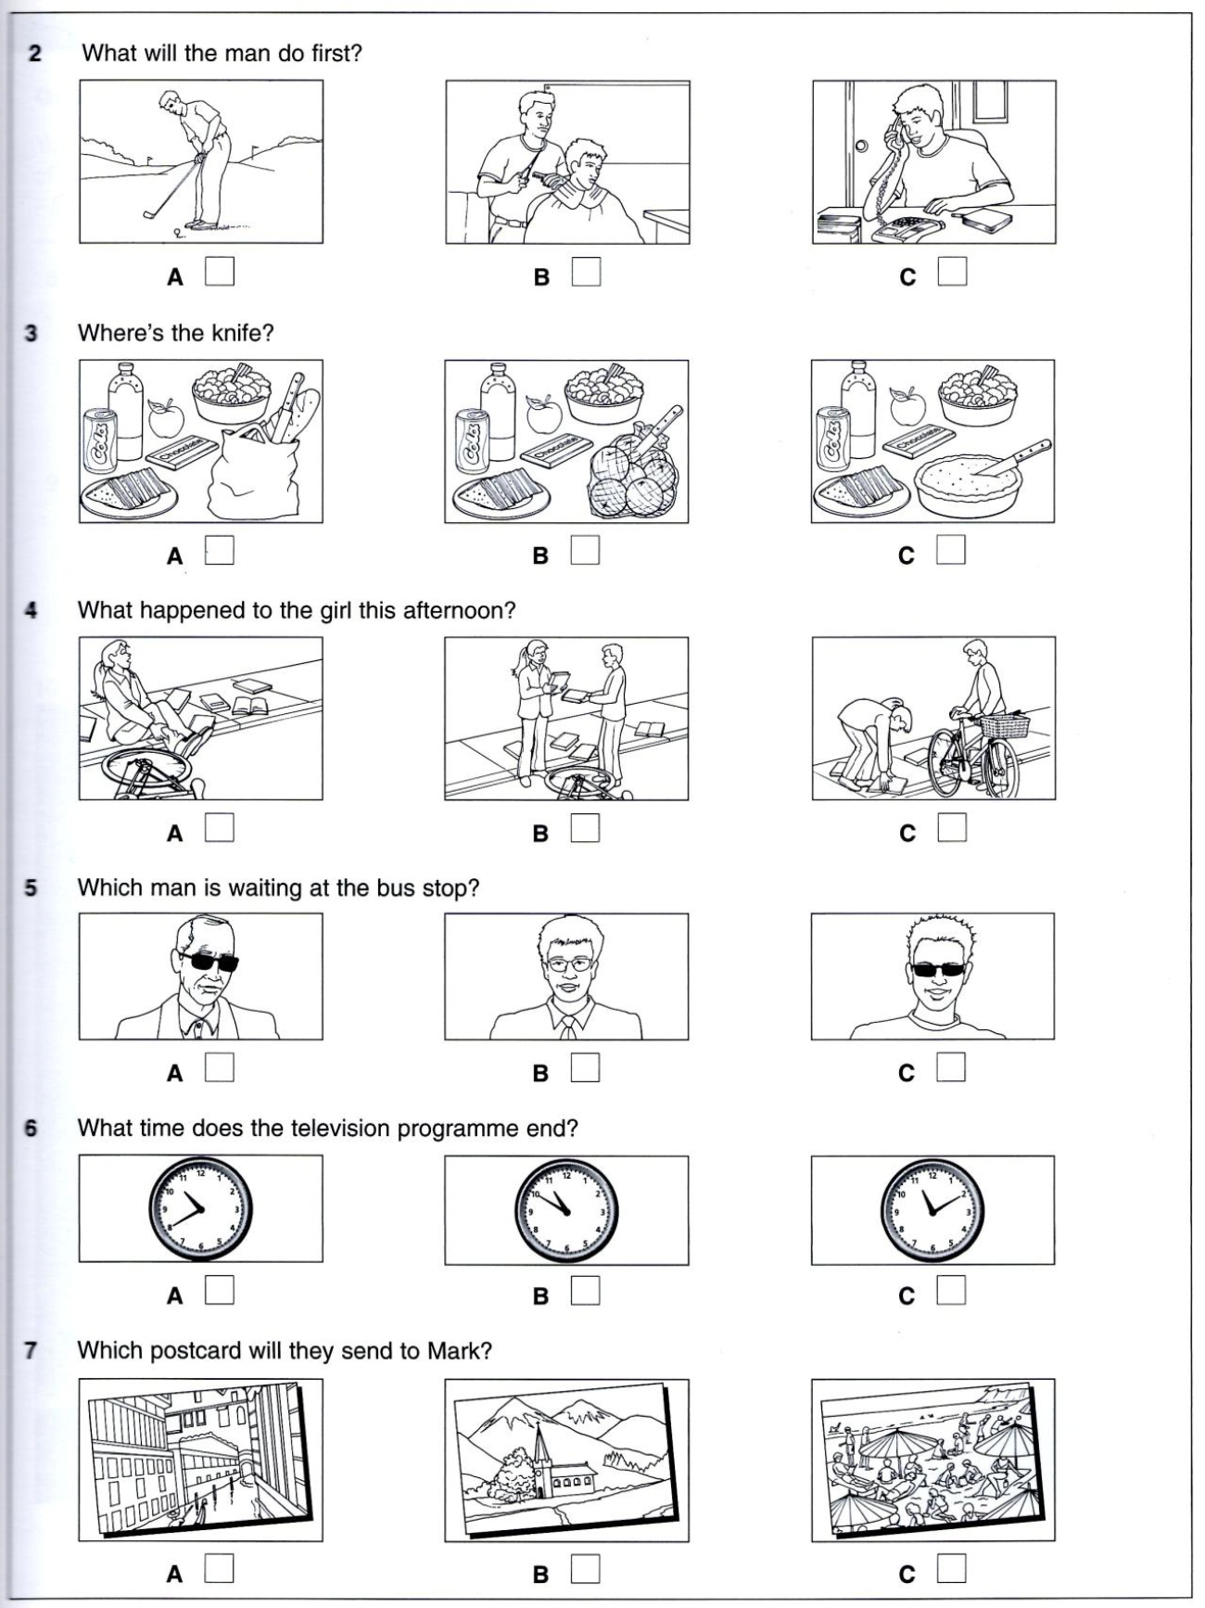

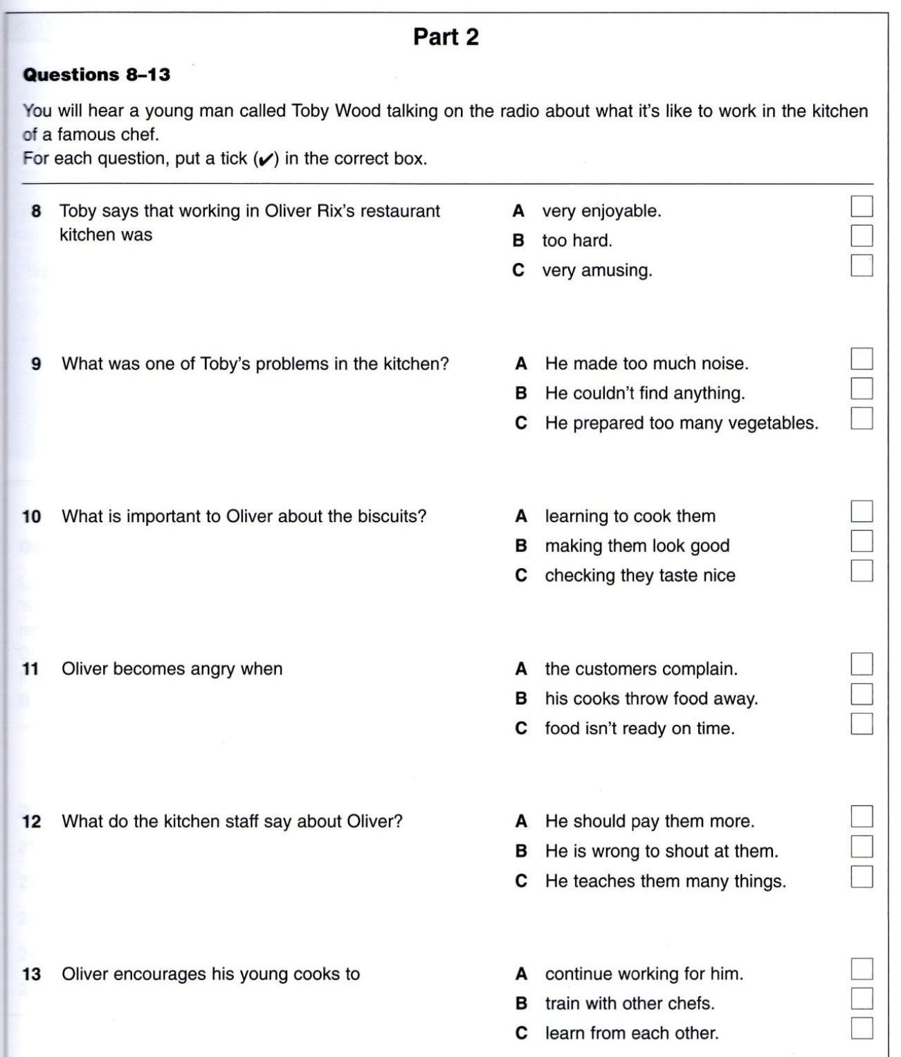

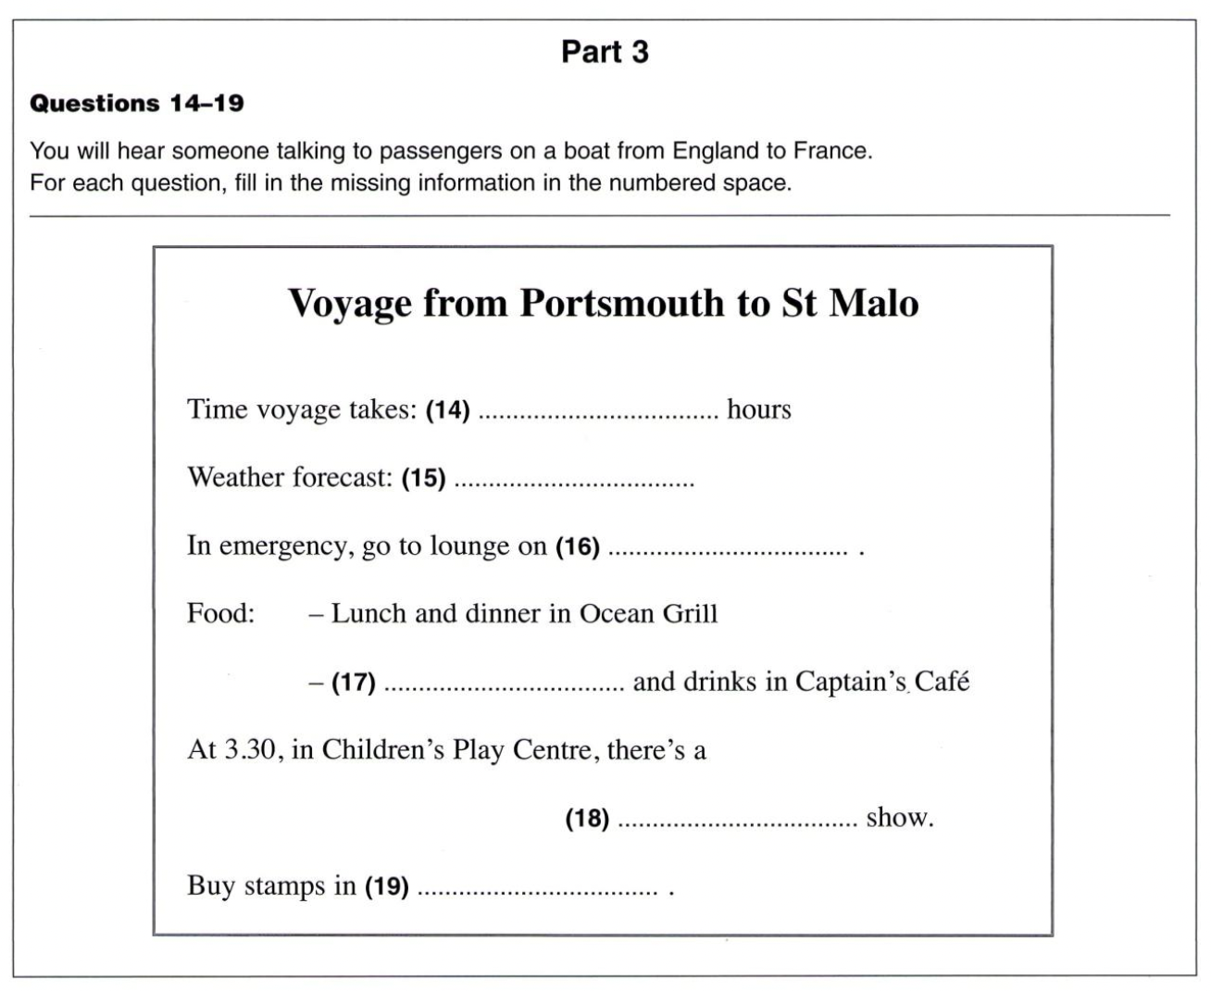

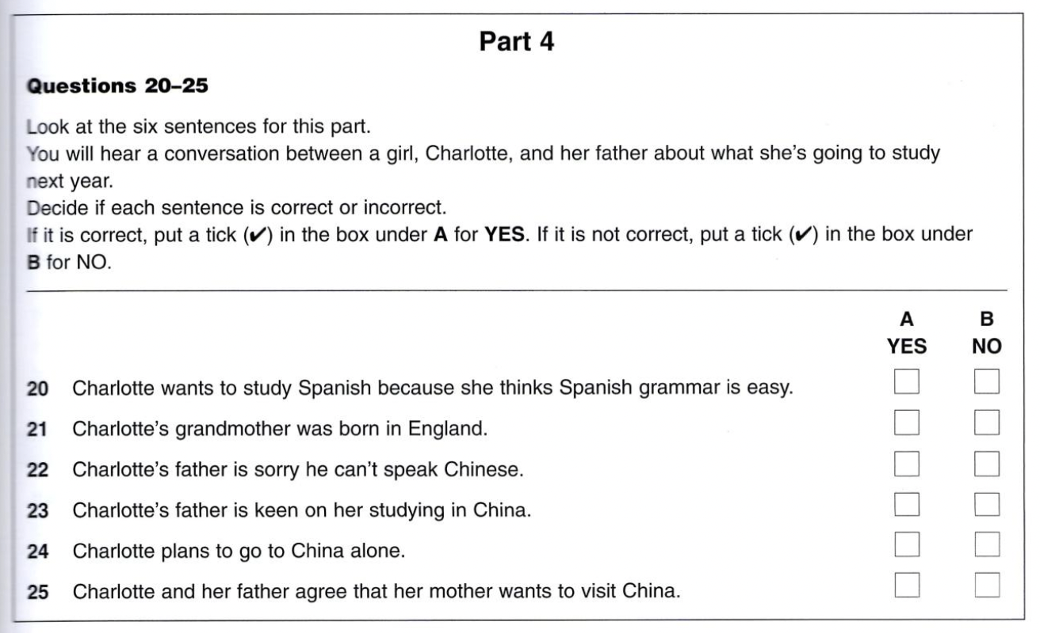

*(Đề thi này gồm có 06 trang)*