**FURTHER PRACTICE 2**

**PART 1**

**Questions 1-5: For each question, choose the correct answer.**

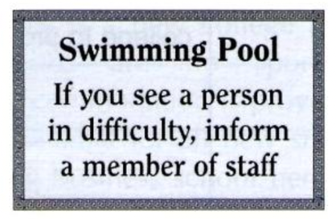**1.** A. If you have difficulty swimming, inform a member of

staff before entering the pool.

B. Tell a staff member if you notice someone is in danger.

C. This pool is for the use of confident swimmers only.

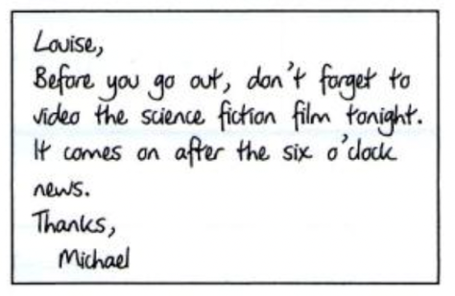**2. Why has Michael written this note?**

A. to remind Louise to tape a film for him tonight

B. to recommend a film for Louise to watch tonight

C. to ask Louise to return the video he borrowed

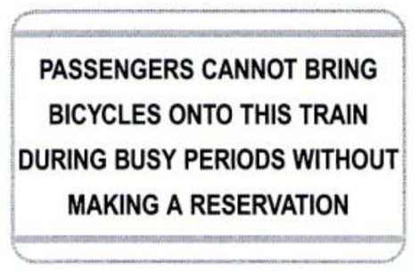

**3.** A. As this train is busy, all passengers must book before boarding.

B. Passengers must book before bringing bicycles

onto the train at certain times.

C. There is no room for bicycles on this train when it is busy.

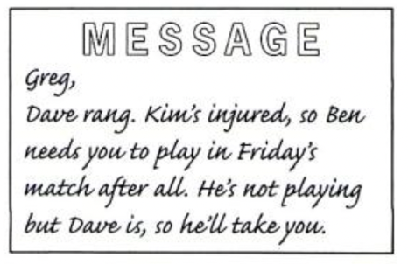**4. Who is going to play in Friday’s match?**

A. Greg and Kim

B. Greg and Ben

C. Greg and Dave



**5.** A. We want to see a copy of the repair form before we return your computer.

B. Customers should fill in a form before leaving their computer for repair.

C. Copies of original repair forms are available if requested.

**PART 2**

***Question 6 -15: Read the text below and choose the correct answer to fill in the gap. (4 marks)***

*Example:*

0. **A. reached**  B. arrived C. got D. went

**CHOCOLATE**

When the Spanish explorer Cortez (0) …………. Mexico in the sixteenth century, he found the people there using a drink they (6) …………. chocolate. It tasted quite strong (7) …………. it had pepper in it. To (8) …………. it taste better, the Spanish added sugar to it. When chocolate first came to Europe in the seventeenth century, people started to drink it with milk, (9) …………. of water. Nowadays, tonnes of chocolate and cocoa are (10) …………. to factories, where they are turned (11) …………. many popular sweets and cakes.

(12) …………. chocolate and cocoa come from the fruit of the cocoa tree. Cocoa trees (13) …………. only be grown in hot countries, as they need a warm climate. Cocoa is an American plant, (14) …………. still grows wild in the northern part of South America. Countries in Central and South America were the first to grow it, but today Africa (15) …………. the world with the most chocolate.

6. A. announced B. told C. called D. declared

7. A. while B. because C. so D. whether

8. A. let B. cause C. allow D. make

9. A. apart B. except C. rather D. instead

10. A. delivered B. directed C. prepared D. produced

11. A. down B. into C. off D. over

12. A. Both B. Every C. Either D. Each

13. A. ought B. can C. have D. might

14. A. what B. which C. who D. whose

15. A. brings B. fetches C. supplies D. gives

**PART 3:**

**Questions 16-25: *Read the text below about a trip to East Africa and decide if each sentence is True (T) or False (F). (4 marks)***

**The Trip of a Lifetime**

Take a trip to East Africa. You begin this trip by visiting the wonderful wildlife parks. As well as travel by coach, there is also an opportunity to take a short trip in a hot-air balloon over the parks to get a better view of the wildlife.

After visiting the wildlife park, you have the choice of either spending the rest of your holiday (7 nights) climbing Mount Kilimanjaro -the highest mountain in Africa – or, for the not so adventurous, sunbathing on the beautiful white sand beside the Indian Ocean. (It is also possible to stay an extra week at the coast.)

**Day One:** Fly from London Heathrow to Nairobi, Kenya.

**Day Two:** Drive to the National Park at Lake Manyara. This park is famous for the large variety of birds, which you can see there early in the morning.

**Day Three:** Leave Manyara for the Serengeti National Park, where you may see elephants, lions and giraffes.

**Day Four**

**to Nine:** Spend these days traveling by coach around the park. All visitors have a window seat on the coach with a clear view for photographs of the park and animals. Although the animals are not worried by tourists taking photos, we ask visitors to speak quietly so as not to disturb them too much.

Accommodation in tents is normal in the parks. All have private washing facilities. The tents have plenty of space, are very comfortable and have a solid floor. The guides are highly experienced, but there is always the possibility that you may be very unlucky and not see certain animals.

**Day Ten:** Departure for the mountain trek or to go the Indian Ocean.

The Indian Ocean Hotel is on the beach and all rooms have air-conditioning and sea views. All water sports are available and there are tennis courts, which you can use free of charge except during high seasons, when there is a small booking fee.

No special skills are needed to climb Mount Kilimanjaro, but if you choose this trip, you must already be fit and healthy and ready to accept some very basic accommodation in mountain huts.

Most tours and safaris can only operate with a minimum number of passengers. If this number is not reached, we might cancel the tour. If this happens, we will make a decision at least 8 weeks before departure and will try to arrange a different holiday. Minimum number can be from 2 to 15 according to the tour.

For practical reasons, children under the age of 8 (under 12 on climbing holidays) may not be accepted on certain tours.

T F

16. You can see animals from the air on this trip.

17. You can spend a fortnight at the beach.

18. It is possible to see large number of birds on Lake Manyara at sunset.

19. Some animals are frightened when visitors use cameras.

20. You are sure to see all the animals you want.

21. You can go windsurfing from the Indian Ocean Hotel.

22. The hotel tennis courts are closed at certain time of the year.

23. Some training is provided if you decide to climb Mount Kilimanjaro.

24. The smallest number of people required on some tours is two.

25. Children can join the Mount Kilimanjaro trip from the age of ten.

**PART 4:**

**Questions 25 -29:** ***Read the text below and answer the following questions. (2 marks)***

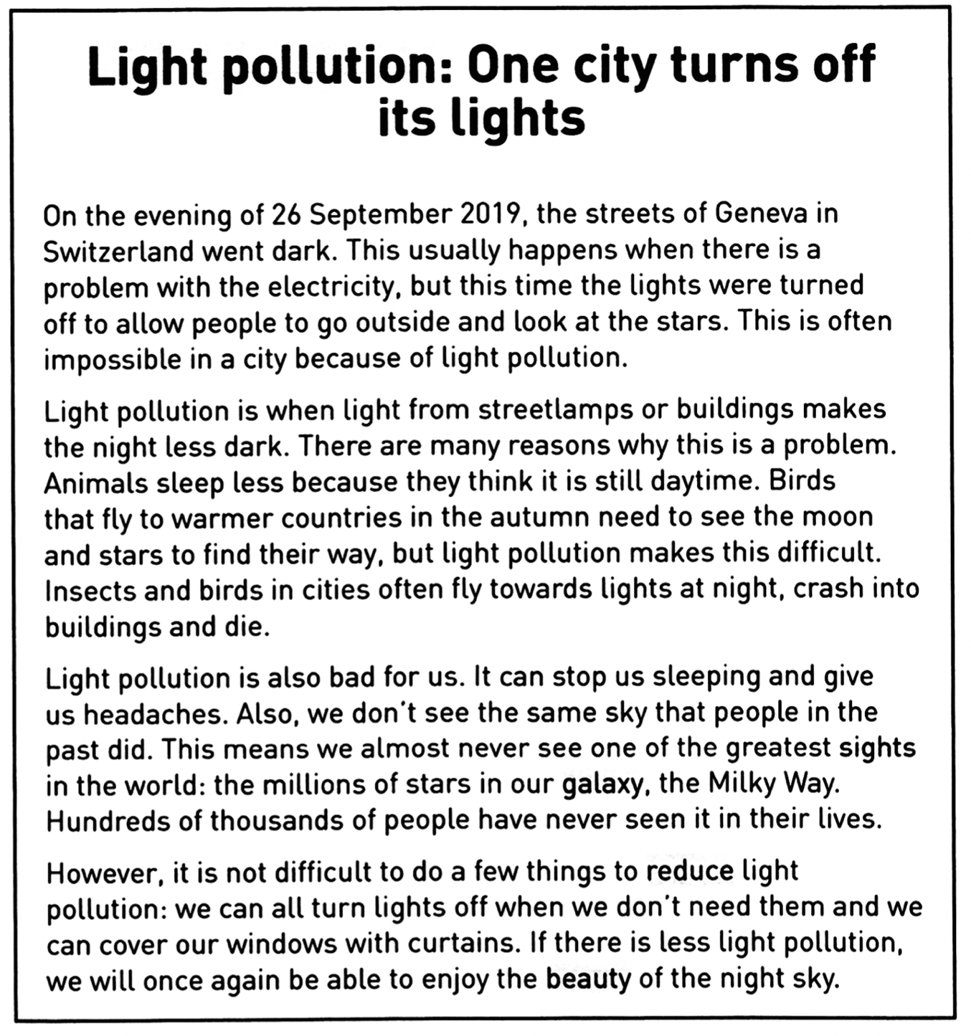

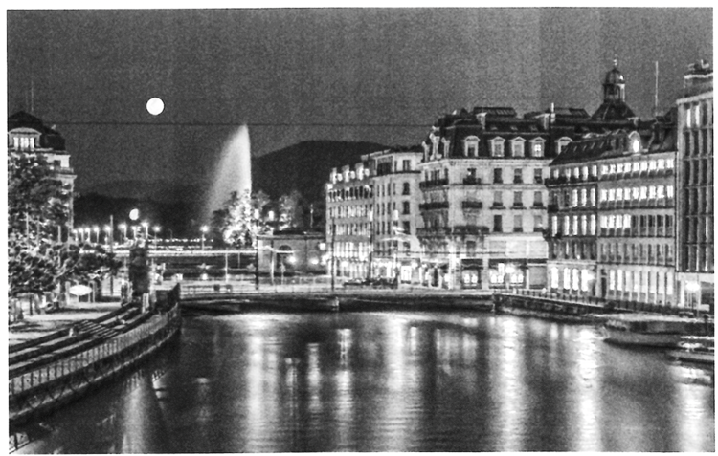

**25. The lights were switched off in Geneva on September**

A. Because there was no electricity in the city.

B. so that people could go out of their houses.

C. to make it easier for people to see the stars.

**26. Light pollution is a problem**

A. when the night is too dark.

B. when it isn’t light enough at night.

C. when there is too much light at night.

**27. Light pollution is bad for some birds because**

A. they get lost more easily.

B. they never sleep.

C. they can’t see so they crash into buildings.

**28. The writer of the article thinks that**

A. people today should learn more about the past.

B. it is a pity that people today can’t enjoy the night sky.

C. a hundred thousand people have never seen the stars.

**29. The writer says that**

A. there aren’t many things we can do to stop light pollution.

B. it is easy to do something to improve the situation.

C. we can enjoy looking at the stars if we cover our windows.