**READING PRACTICE 1**

**PART 1**

**Questions 1-6: For each question, choose the correct answer.**

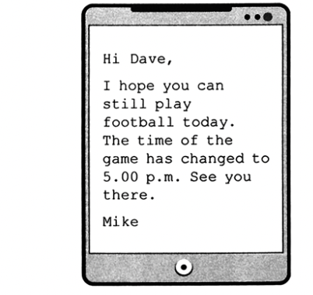1. A. Dave and Mike will go to the game together.

B. Mike thinks Dave wants to change the time of the game.

C. Mike wants Dave to know the time of the game.



2. A. Somebody wants a cleaner with no experience.

B. Somebody wants a cleaner and experience is not important.

C. Somebody wants a hard-working cleaner with no experience.

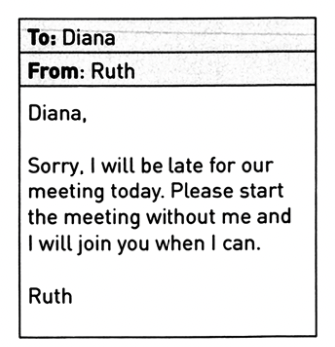

3. A. Ruth will come to the meeting after it starts.

B. Ruth wants Diana to wait for her before the meeting.

C. Ruth will start the meeting later than she planned to start it.

4. A. After 5 p.m. bananas will be more expensive.

B. You can only buy bananas today.

C. Before 5 p.m. there is no special offer.

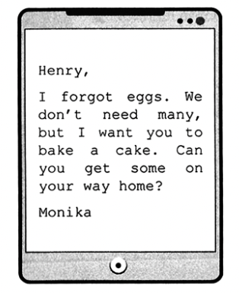

5. A. Monika wants to bake a cake.

B. Monika wants Henry to buy eggs.

C. Monika doesn’t need eggs.

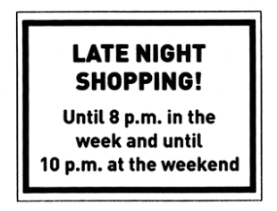

6. A. On Mondays, you can shop at 9 p.m.

B. On Fridays, you can only shop after 8 p.m.

C. On Saturdays and Sundays, you can shop at 9 p.m.

**PART 2**

**Question 8-14: *For each question, choose the correct answer.***

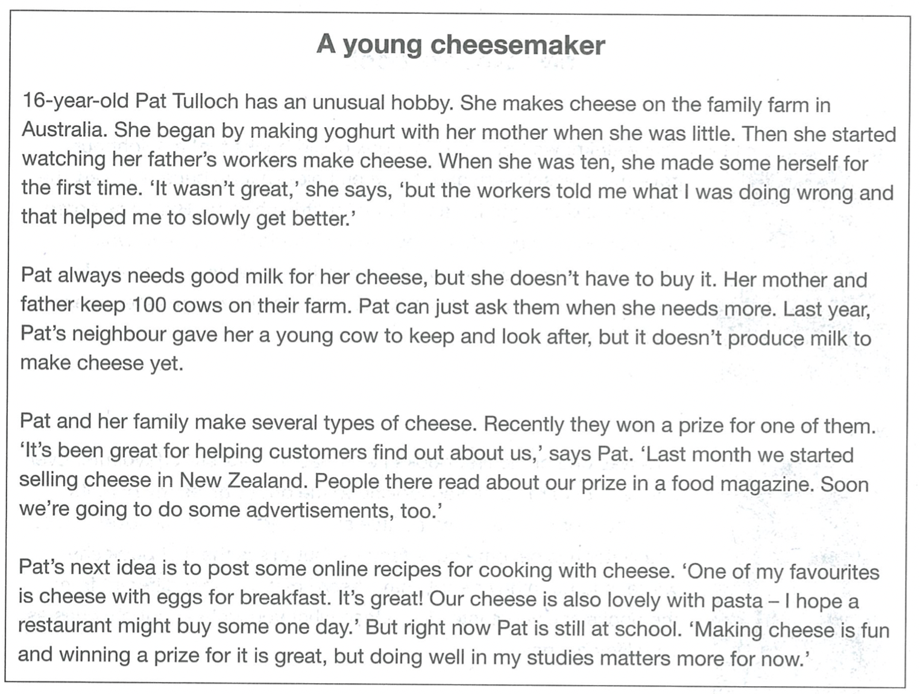

7. Pat learned to make good cheese

A. by listening to the device she got.

B. By seeing how her mother did it.

C. by practicing at home on her own.

8. Where does Pat get the milk for her cheese?

A. from her neighbor’s farm

B. her father helps her to buy it

C. her parents give it to her

9. Pat says winning the prize means

A. more people know about her family’s cheese.

B. she can be the star of the family’s new advertisement.

C. she was invited to visit another country.

10. What’s the most important thing for Pat at the moment?

A. writing a new cookbook

B. being successful at school

C. selling cheese to a restaurant

11. In this article, Pat is explaining

A. why her family started making cheese.

B. how to win a competition for making cheese.

C. how she has become part of a cheese-making business.****

**PART 3**

**Questions 14-18: *For each question, choose the correct answer.***

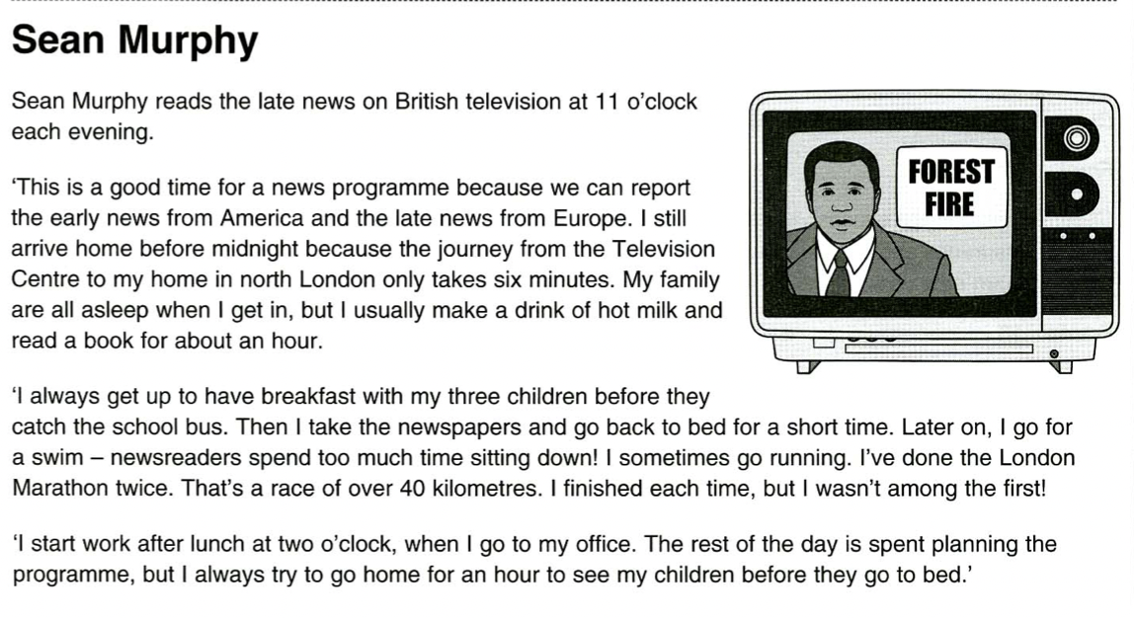

12. The late news begins at 11 o’clock every evening.

A. True B. False C. Doesn’t say

13. Sean Murphy lives in London.

A. True B. False C. Doesn’t say

14. Sean takes his children to school in the morning.

A. True B. False C. Doesn’t say

15. Sean likes to go swimming with his colleagues from work.

A. True B. False C. Doesn’t say

16. Sean has won the London Marathon.

A. True B. False C. Doesn’t say

17. Sean’s working day begins in the afternoon.

A. True B. False C. Doesn’t say

18. Sean usually leaves the office for an hour during the evening.

A. True B. False C. Doesn’t say

**PART 4**

**Questions 16-20: *For each question, choose the correct answer.***

**Online shopping**

Online shopping has (19)…………… very popular. With a click of a mouse on your computer, you can buy anything you want. It is much easier than going into town, looking around lots of different shops. You can also see what is (20)…………… in stores all over the world when you shop online.

Another good reason (21)…………… shopping on the internet is that you don’t have to carry heavy bags of shopping home. Online (22)…………… just send your order to your house, usually, in a few days.

One big problem with online shopping, however, is that you can’t (23)…………… on any clothes before you buy them. And often, when you get your clothes, they look very different from the online pictures. They may also be larger or smaller than the (24)…………… you wanted. As a result, many people often have to (25)…………… clothes they bought on the internet.

19. A. done B. become C. seemed

20. A. favourite B. available C. comfortable

21. A. which B. for C. why

22. A. lorries B. offices C. companies

23. A. try B. turn C. look

24. A. size B. weight C. number

25. A. get B. give C. return

**- THE END -**