HOEIT Time allotted for 03 periods
Lesson plan number: 05 Done:
UNIT 6. HEROES
OBJECTIVES
By the end of the lesson, students will be able to:
Knowledge:
- Infer word meaning from context
- Categorize words with similar meanings
- Use signal phrases in presentations
Skills:
- Improve language skills: speaking and listening,
- Express opinions
- Ask follow-up questions
- Recognize and use signal phrases in presentations
- Give a presentation
Attitude:
- Be active, excited and enthusiastic in learning.
- Build a habit of using English in their careers.
TEACHING AIDS AND MATERIALS:
Teaching aids:
- LCD projector, screen, computer, blackboard, chalk, PowerPoint
Materials:
- Textbooks and references
- Course book:
Frazier, L. & Mills, R. (2009). NorthStar: Listening and speaking Level 2 (3rd ed.). New York: Pearson.
2. References
1) Brooks, M. (2011).Q:Skills for Success 2 Listening and speaking. Oxford: OUP.
2) Falla, T. & Davies, P. A. (2007). Pre-Intermediate Solutions: Students’ book. Oxford: Oxford University Press.
3. Website for PET practice tests:
http://www.flo-joe.co.uk/pet/students/tests/
http://www.examenglish.com/PET/pet_speaking.html
I. CHECKING ATTENDANCE
Time: 2 minutes
Greeting students and checking attendance
II. NEW LESSON
NO | CONTENT | TEACHING AND LEARNING ACTIVITIES |  | TIME
NO | CONTENT | TEACHER'S ACTIVITIES | STUDENTS' ACTIVITIES
1 | LEAD-IN  - Watch a video of doctors who have worked hard to help the infected in the Covid-19  - Questions:  - What do you think of the doctors?  - What do people call them recently?  - What does the word hero mean to you?  - Can you think of any famous heroes? What do you think an “everyday hero” is?  - Lead-in: They have no magic. They can’t fly, or transform into another creature, but all above, they are real heroes in the real life | Play the video and ask Ss to answer the questions  Ask Ss to think some more heroes  Ask Ss to compare the answers as a class | Watch the video & answer the questions  List some heroes  Give the ideas
2 | PART 1: VOCABULARY  - Community  - Courage  - Role-model  - Praised  - Reacted  - Turned out  - Generous  - Do good deeds  - Have a good heart  - Make a difference  - Show concern for  - Get involved  - Take risks  - Volunteer  - Admire  - Contribute  - Inspire  - Recognize | Use P, M, F, A to teach words  Divide Ss into 3 groups and guide them to do the task  Ask Ss to work in group to match the statements and words. Which group get more correct words is the winner | Work out the meanings and practice the words  Work in group and write the results on the blackboard
 | PART 2: CREATE  Work in a small group. Take turns asking and answering the questions. Use the boldfaced words and vocabulary from Review and Expand in your answers  - Do you think it is a good idea for real-life superheroes to get involved in their communities to stop crime? Do you think they take too many risks?  - Do you think we are responsible for caring for others in our community? Do you think one person can make a difference in other people’s lives? Why or Why not?  - Do you volunteer in your community? If not, what kind of volunteer work do you think your community needs the most?  - Name a person you know who is altruistic. Why do you think this person likes to help others? Give an example of something this person did that was generous or shows they have a good heart  - Name a person you know who has courage. Why do you think this person is brave?  - Name a person you think is a good role model for others. What does this person do to inspire others? | Ask Ss to work in pairs, ask and answer the questions | Work in pairs and do the task.
 | PART 3: EXPRESSIONS  1. Introducing your presentation    2. Making transitions    3. Concluding your presentation   | Introduce the expressions  Ask students to give examples | Listen and take notes  Give examples
 | PART 4: FINAL SPEAKING TASK  STEP 1: Think of a topic.  Think of someone that you admire. It can be someone you know, or it can be someone famous that you know about  STEP 2: Plan your presentation  Complete the chart by researching and taking notes about the person. Be sure to list at least three reasons you admire this person and include details and examples. See the outline  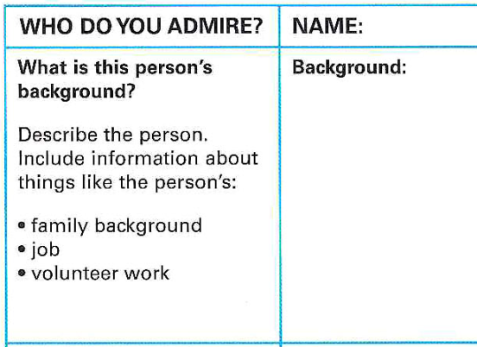  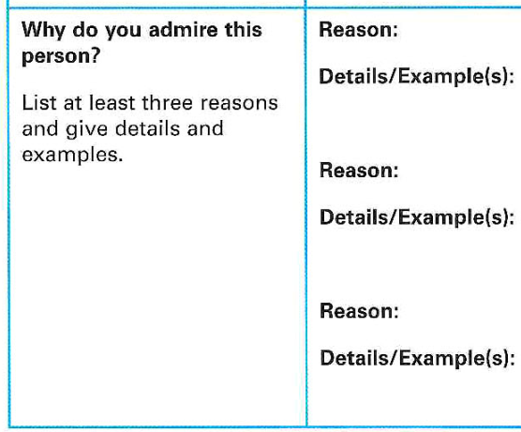  STEP 3: Make an outline. Write your outline on a separate piece of paper  STEP 4: Practice your presentation with a partner. Use your outline and include signal phrases to introduce your topic, make transitions and make a concluding statement. Get feedback from your partner  STEP 5: Deliver your presentation to the class. Your classmates will listen, take notes, and ask questions when you are finished. | Ask ss to form in group, think of a topic.  Ask each group to read the guidance and do their task  Invite the groups to present their topic. | Work in groups and think of a topic  Read the guidance and  do their task  Present the topic
 | PART 5:  ALTERNATIVE SPEAKING TOPICS  Work in a small group. Read and discuss the quotes. What do they mean to you? Explain each quote in your own words. Do you agree or disagree with the quote? Explain.  - “You must be the change you want to see the world” (Mahatma Gandhi)  - “From what we get in life, we make a living. From what we give, we make a life” (Arthur Ashe)  - “The world is a dangerous place, not because of those who do bad things, but because of those who look on and do nothing.” (Albert Einstein)  - “Work for something because it is good, not just because it stands a chance to succeed.” (Vaclav Havel)  - “And the trouble is, if you don’t risk anything, you risk even more.” (Erica Jong)  - “I’d rather die for speaking out than to live and be silent.” (Confucius) | Ask Ss to work in groups and discuss the quotes | Work in groups  And discuss the quotes
3 | CONSOLIDATION  - Infer word meaning from context  - Categorize words with similar meanings  - Use signal phrases in presentations  - Express opinions  - Ask follow-up questions  - Recognize and use signal phrases in presentations  - Give a presentation | Consolidate key points of lessons  Ask ss to give example  Check ss' understanding | Listen and take notes  Answer the questions
4 | HOMEWORK  Go on the Internet or ask people in your community to find an organization that is trying to solve this problem.  - What is the name of the organization?  - How many people volunteer or work for this organization?  - What do they volunteers do to help others? Give examples  - Would you like to join this group? Why or why not? | Guide ss how to do the unit project | Listen and take notes
Teacher in charge

Dương Thị Hồng Phúc

